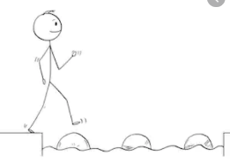
Year 1 Reading
Steppingstone activity (scroll down for a longer text)
Date: Thursday 2nd April 2020
LO: To answer questions about a text
Success Criteria:
- Here is a non-fiction text for you to read. Non-fiction gives you information.
Read it.
2. Talk about what you have read.
3. Answer the questions about it.
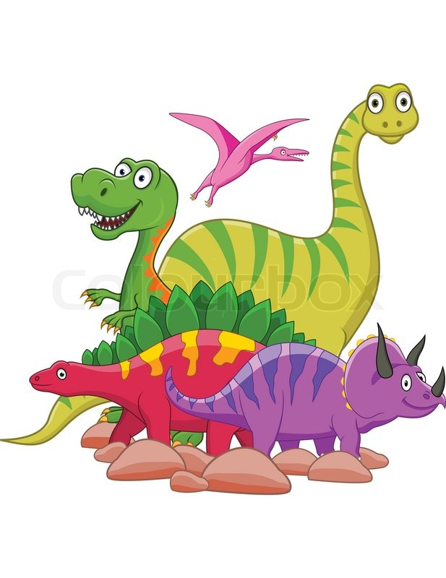
Dinosaurs
Dinosaurs lived a long time ago. They lived on the land and could move very fast. They laid eggs.
Size
Some dinosaurs were as small as a hen. Some were as big as a house. Some were the same size as you.
Food
Some dinosaurs ate meat. Most ate plants.
Fossils
We know about dinosaurs because people found their bones. The bones tell us where dinosaurs lived, what they ate and what they looked like.

Questions

How do we know about dinosaurs?

What did dinosaurs eat?

Were all dinosaurs the same size?

Find out some more information about dinosaurs. Can you find the names of dinosaurs? What did they look like? Were all dinosaurs friendly?

Write about what you find out about dinosaurs

Year 1 Reading
Date: Thursday 2nd April 2020
LO: To answer questions about a text
Success Criteria:
- Here is a non-fiction text for you to read. Non-fiction gives you information.
Read it.
2. Talk about what you have read.
3. Answer the questions about it.

Dinosaurs
Dinosaurs lived on the Earth millions of years ago, before there were humans. The word dinosaur means “terrible lizard”. Dinosaurs are reptiles and not lizards. They lived on the land, and could move very fast. They laid eggs and had scaly skin.
Size
Some dinosaurs were as small as a hen. Some were as big as a house. Some were the same size as you.
Food
Some dinosaurs were hunters. They ate meat. Others ate plants; the special name for an animal that eats plants is herbivore. Most meat eating dinosaurs walked on two feet. Walking on two feet helped them to move faster and left their hands free to catch their prey.
Fossils
We know about dinosaurs because people found their bones. The bones tell us where dinosaurs lived, what they ate and what they looked like. We know that some dinosaurs walked on two legs, while others walked on four. There are no dinosaurs left on Earth. We are not sure why.

Questions

How do we know about dinosaurs?

What did dinosaurs eat?

Complete the following sentence
Most hunter dinosaurs walked on two feet. This helped them to _____________

Were all dinosaurs the same size?

Find out some more information about dinosaurs. Can you find the names of dinosaurs? What did they look like? Were all dinosaurs friendly?

Write about what you find out about dinosaurs in your books.

