Year 5 Science
Lesson 1
LO: To observe and identify similarities and differences
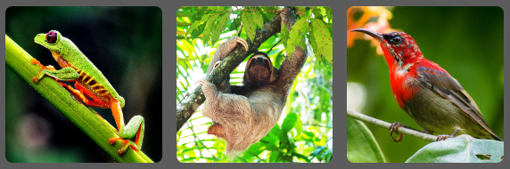
These are three tree-dwelling animals.

Sloths live in the rainforest canopies of Central and South America and have developed long claws to hang from branches. They are solitary creatures that travel from tree to tree using canopy vines as ropes. They feed on leaves buds and shoots but need little food as they have a very slow metabolic rate and may not move more than 40m in a day. Although tree dwellers they are also strong swimmers and drop down from the canopy to swim to new areas of forest, perhaps in search of a mate.
Nicknamed the 'monkey frog' because of their ability to jump, the red-eyed tree frog has sucker pads on each digit to help them stick to leaves. They sleep during the day stuck to the underside of a leaf. Their bright colouration acts as a warning to potential predators.
The crimson sunbird lives in the tropics of south eastern Asia and is only 12 cm long. Only the male has the vivid crimson breast. It has a long beak to collect nectar and talons to help grip on tree branches. Many plants rely on the bird to pollinate their flowers.

Task:
Look at the images above and come up with as many similarities and differences between these animals.
Think about the following:
- appearance
- what they do
- where they might be found
Decide on which one is the odd one out and why. How many different ‘odd one out’ examples can you find?
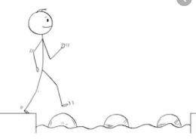
Year 5 Science
Steppingstone activity
Lesson 1
LO: To observe and identify similarities and differences
These are three tree-dwelling animals.

Sloths
- Live in the rainforest canopies of Central and South America
- Have long claws to hang from branches.
- Travel from tree to tree using vines as ropes.
- Eat leaves buds and shoots but need little food
- Cannot move more than 40m in a day.
- Strong swimmers and drop down from the canopy to swim to new areas of forest.

Crimson sunbird
- Live in south east Asia and
- Is 12 cm long.
- Only the male has the vivid crimson (red) breast.
- It has a long beak to collect nectar and talons to help grip on tree branches.
- Many plants rely on the bird to pollinate their flowers.

Monkey frog
- The frog has sucker pads on each digit to help them stick to leaves
- They sleep during the day stuck to the underside of a leaf.
- Their bright colour acts as a warning to potential predators (animals that’ll eat them)

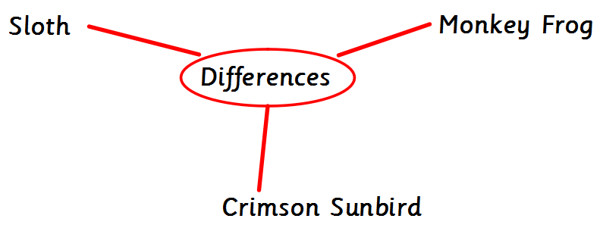
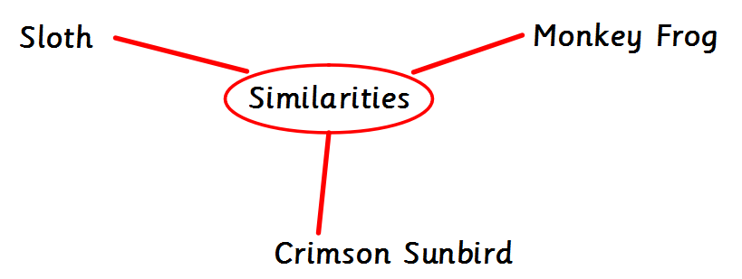
Task:
Look at the images above and come up with as many similarities and differences between these animals.
Think about the following:
- appearance
- what they do
- where they might be found

