Year 1 Science
Lesson 1
What do plants need to grow?
LO: To know some of the things that a plant needs in order to grow well
Task (with links):
You are going to be designing a leaflet telling me what plants need to grow well.
You can use whatever resources you have at home (pencils, felt tips, crayons). Be as creative as possible!
Think about the features of a plant. Label your plant.

Success Criteria:
- Read the information about what plants need to grow
- Design a leaflet informing people about what plants need in order to grow
- Read the additional information about the parts of the plant
- Label your plant explaining the job of each part

https://www.bbc.co.uk/teach/class-clips-video/science-ks1-ks2-ivys-plant-workshop-what-do-plants-need-to-survive/zkw2gwx
What do plants need to grow?
- Water
Plants need water to help them grow. Without water a plant will dry up and die.
- Light
Green plants need sunlight so that they can make their own food.

- Nutrients
Plants need good food found in soil for healthy growth.
- Warmth
The sun gives a plant warmth as well as light. Plants grow best in the right conditions. A plant does not grow well if it is too HOT or too COLD.
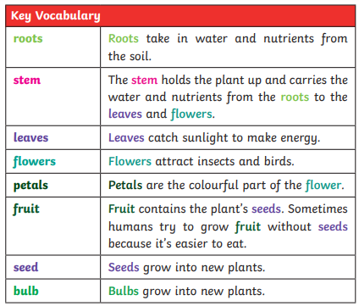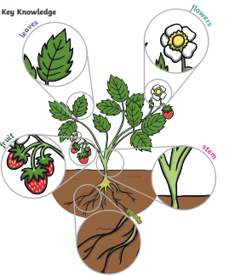

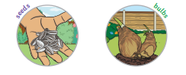

Revision
Ask your children:
What does a plant need to grow well?
To name the parts of a plant and know what job they have.

Answer the following questions about plants

Without this a plant will die. ______________

To grow, a plant needs _____________________ and ____________________.

This helps a plant make its own food. _________________

These are found in the soil. ____________

nutrients warmth sun water

