Year 6 Science
Week 1
Success Criteria:
- Observe the animals list (use the internet to research an animal if needed).
- Organise the animals into groups of your choice.
- Choose a chart or table to represent your groupings.
- Watch the video links at the bottom of the page.
- Regroup your animals using different grouping headings (use new vocabulary).
Task 2
Watch the video clips at the bottom of the page.
Now try and regroup the animals using characteristics and new vocabulary that you have been introduced to.
Task (with links):
Our new topic this term is…
Living things and their habitats.
Task 1
Here are some animals.
How could you group them? Organise the animals into different groups, using your knowledge of animals and their characteristics. You can present the information in a table, list, Venn diagram, etc.
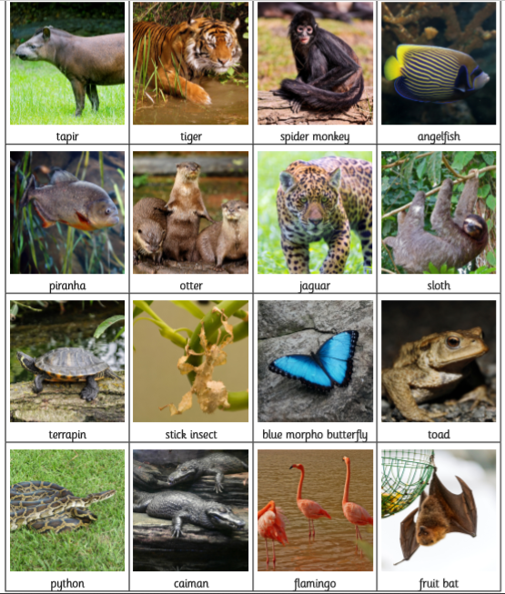
Helpful websites.
https://www.bbc.co.uk/bitesize/topics/zn22pv4
https://www.youtube.com/watch?v=-LVunuIOT4w
https://www.bbc.co.uk/programmes/p004j5rl

