Year 5 Science
Lesson 3
LO: To identify and describe parts of a plant
This term we will be learning about Living things and their Habitats
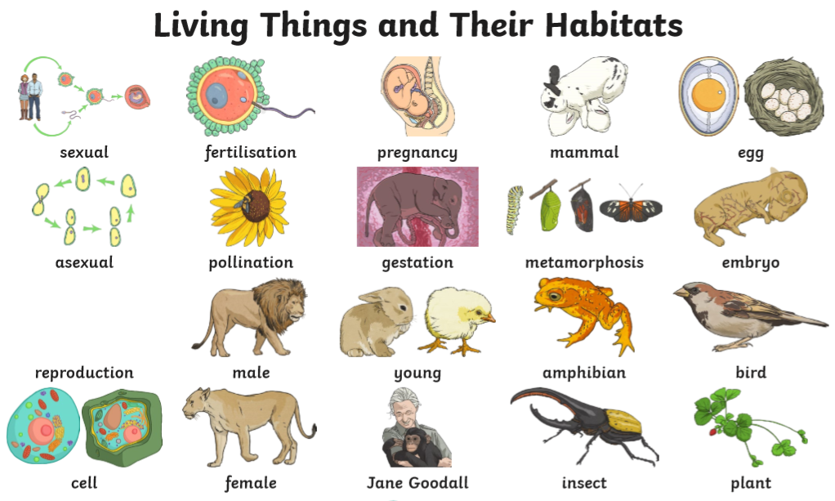
What do you know about living things? Think back to things you previously learnt i.e. Mrs Nerg.
What are the characteristics of a living thing?

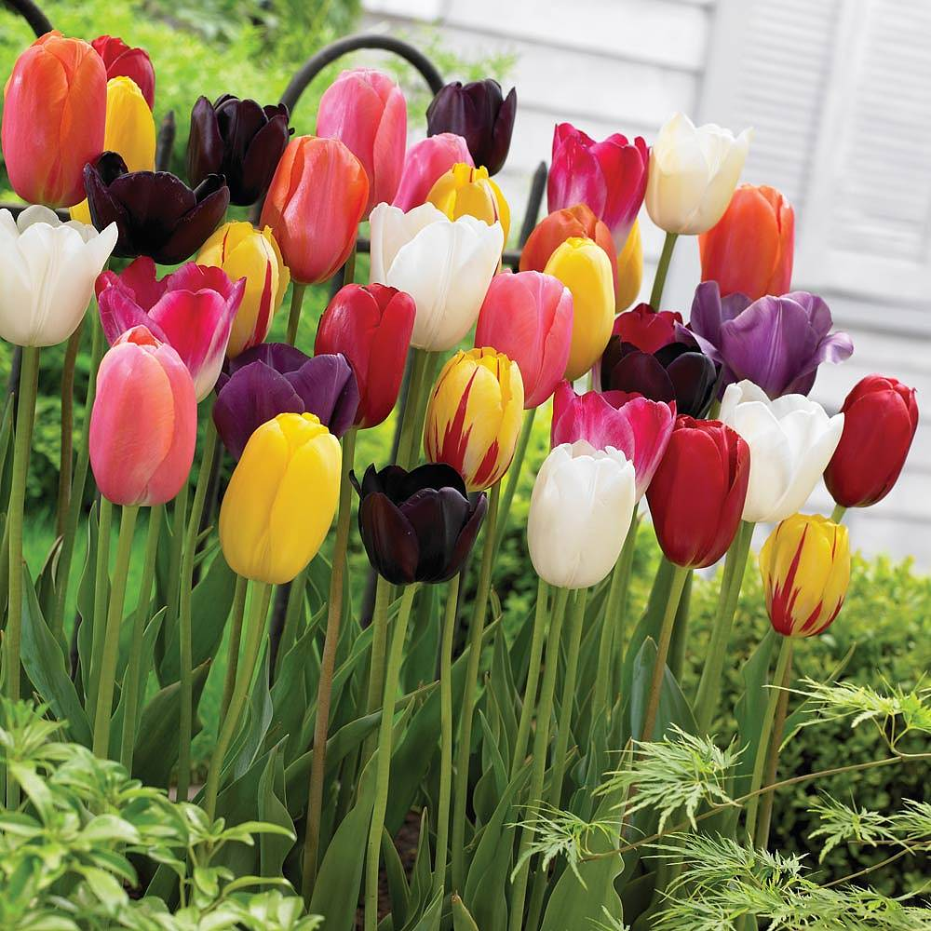
Task:
1. Complete a knowledge harvest based on what you know about living things and their habitats. Use the questions below to guide you. You can set this work out in a grid or a thought bubble
- How do we know something is living?
- What do we mean by habitat?
- Name as many life processes as you can.
- What do we mean by a life cycle?

2. Using a flower gently pull it apart to explore and identify different parts within it. Create a visual of the different parts of a flower by sticking/taping it into your books and label as many parts as possible.

3. Identify the different functions of the following parts of a plant.
- anther
- filament
- stem
- ovule
- ovary
- style
- stigma
- petal
- pollen tube

