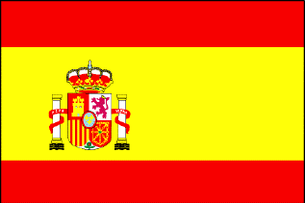
Year 2 Spanish

Year 2  Spanish Online Home Learning  Week2 | ¡Hola! Dear Year 2. ¿Como estas? I am well and missing you all. I hope you are well too. I have prepared some materials for you to have fun and practice your Spanish at home. This week you will only focus on this activity. I will be sending more in the following weeks.  Activities:  Stand up and Sing the song Head, shoulder knees and toes in Spanish with this song https://www.youtube.com/watch?v=hEcivwH6wVc  Next practice numbers up to 20 in SPANISH with this song: https://www.youtube.com/watch?v=6FEyfy5N3Nc  Then watch a group of Spanish children play Abuelito, ¿qué hora es?, a Spanish playground game similar to Granny’s footsteps. They count in Spanish using numbers 1-10 as they play taking footsteps in the style of different animals. Canguro (Kanguro)/Jirafa (Giraffe) /Hormiguita (little ant). Try it!

