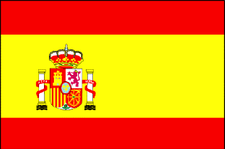

**Year 4 Spanish**

|  |  |
| --- | --- |
| ***Year 4***  *Spanish Online Home learning*  ***Week2*** | *¡Hola! Dear Year 4. ¿Como estas? I am well and missing you all. I hope you are well too. I have prepared some activities for you to practice your Spanish at home. This week you will only focus on this activity. I will be sending more in the following weeks.* *Celebrating a birthday in Spain* ***Introduction:*** *Llorens is celebrating his birthday with friends and family. As he receives gifts from his friends, his mother is preparing the food for the party - paella. She shows us the ingredients for the dish and how she makes it. We are then introduced to Llorens's big family. The family sits and enjoys the delicious dish. After such a big meal the adults go for a sleep, leaving the kids to play a trick on them.*  *Play clip* [*https://www.bbc.co.uk/bitesize/clips/z2y6n39*](https://www.bbc.co.uk/bitesize/clips/z2y6n39)  ***Activity:*** *Discuss about the differences between celebrating a birthday in Spain and the UK. Children could be encouraged to list the main differences and then write a description (in English) of how they celebrated their last birthday.* |