Year 6 Topic: Extreme Earth Activity Week 4
L.O. To use knowledge and understanding of the earth’s structure to understand how a volcano is formed.

e) Add the names of the following volcanoes to your world map. Add more if you’d like!
Vesuvius, Italy Eyjafjallajökull, Iceland
Mount Fuji, Japan Kīlauea, Hawaii
What and where are the earth’s tectonic plates and how are they linked with volcanoes?
Task 1
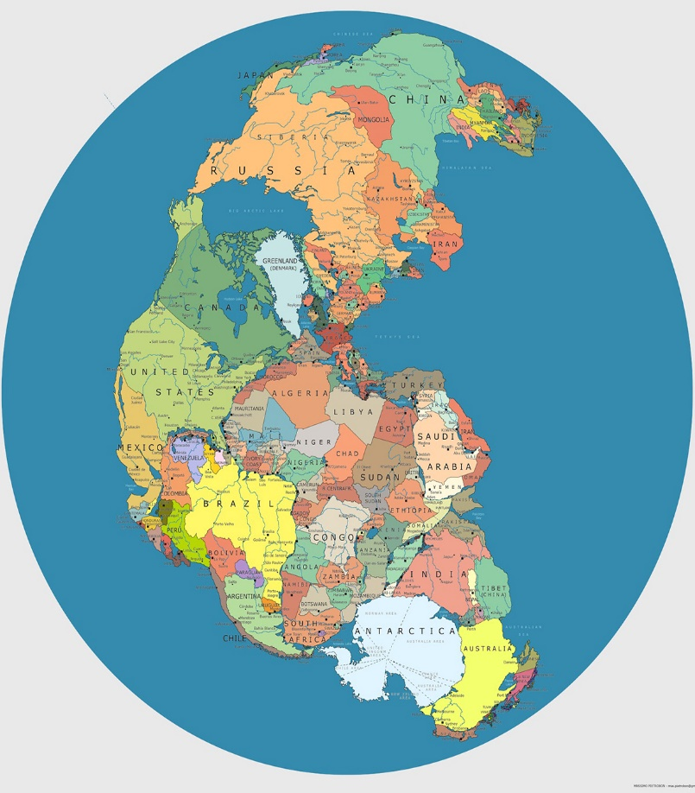
Watch the videos about the structure of our Planet.
https://www.bbc.co.uk/programmes/p00fztwb
https://www.bbc.co.uk/bitesize/guides/zwcfxsg/video

a) Copy the Blank map of the world below, onto a full page in your book. Don’t worry, it doesn’t have to be perfect!

b) Add the names of the continents to the map.

Europe Africa North America South and Central America

Australasia Asia Antarctica

c) Write a description of how the continents moved over 250 million years. Include the vocabulary below. Re-watch the videos to help you!

Tectonic plates moved separated divided

Mantle continents millions of years

d) Look carefully at the world map, can you see the fault lines? These are the places where volcanoes and earthquakes are most likely to happen. Choose the best explanation for this, from below and add to your world map,

1) The plates move and crash.
2) Tectonic plates move on the mantel, at the edges, the plates overlap or collide, this creates pressure which eventually leads to an earthquake.
3) These are lines, which show the edges of the plates and the lava comes up between them.

