Year 1 Topic
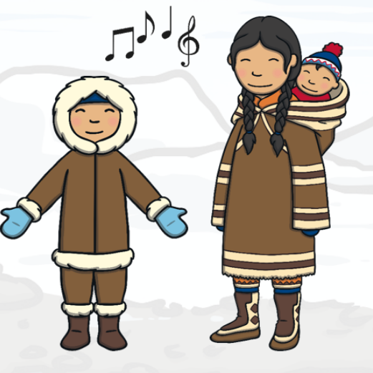
Lesson 1
What do we know about the Inuit people?
LO: To make a fact file about Inuits

Over the last few weeks we have been learning all about the Inuit people. You are going to make a booklet/fact file about them.
Include some of the following subheadings:
Who are the Inuits and where do they come from?
What do they wear and why?
Where do they live?
What do they eat?
How do they travel?
Other interesting facts about the Inuit people
Eg throat singing.
Don’t forget to include pictures with labels!

If you need help remembering what you know about them use the fact sheet below.
