Year 1 Topic
Lesson 2
How can we save our planet?
LO: To make a poster showing how we help to stop climate change

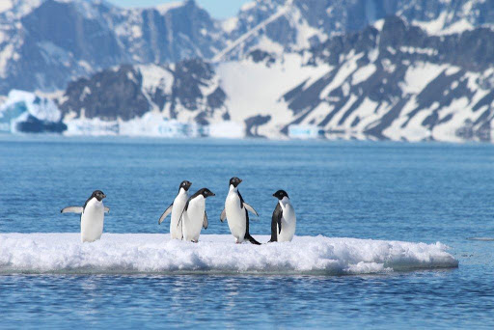
Climate change means that the polar ice caps are melting and polar animals are losing their habitats.
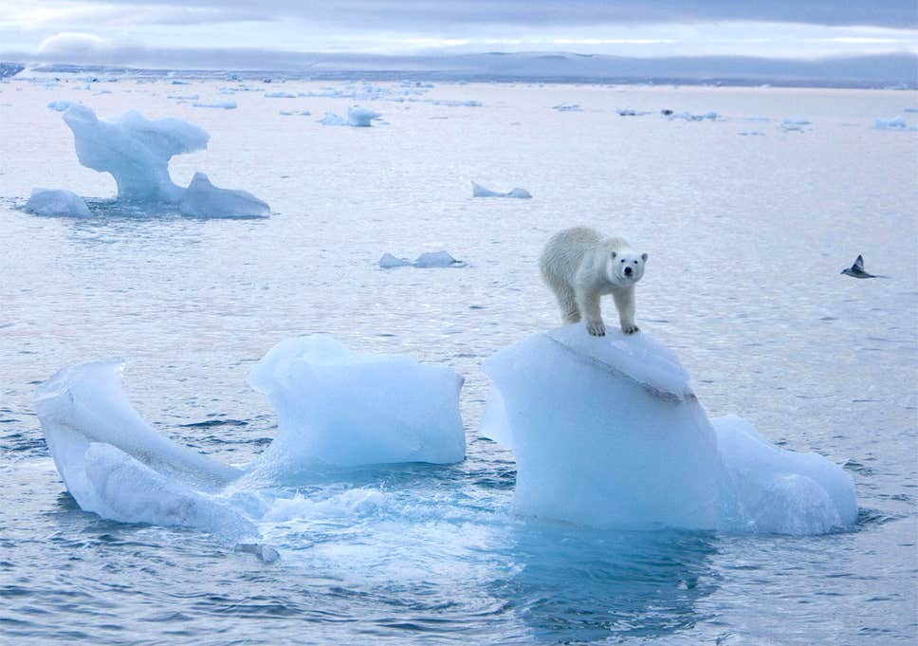

What can we do to stop this happening?

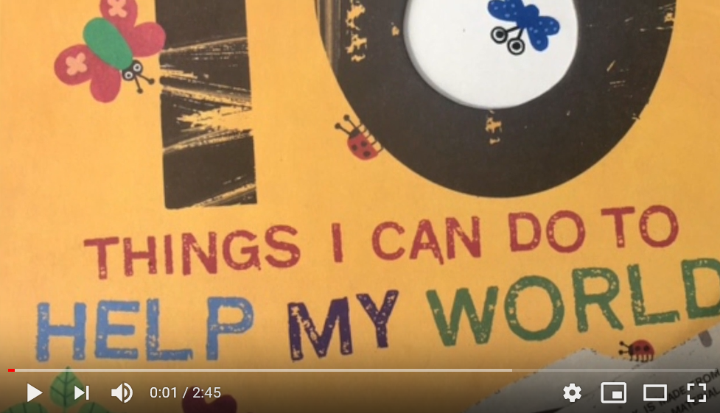

Listen to the story of 10 Things I can do to help my world.
https://www.youtube.com/watch?v=xTN6T74W4L8.

Make a poster showing different things we can do to stop climate change.

