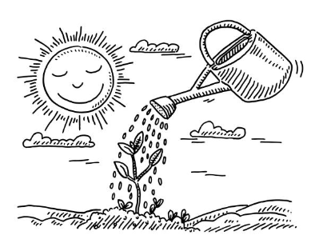
Year 1 Science
Lesson 2
What do plants need to grow?
LO: To make predictions
Task (with links):
You are going to be predicting what will happen to seeds when they are planted and left in different places.
A prediction is a statement that you make saying what you think will happen
You will draw what you think will happen to the seed when planted
- In the dark
- Without soil
- Not given water
- And given water, soil, sunlight
Which plant do you think will grow the best and why?
You can use whatever resources you have at home (pencils, felt tips, crayons).

Success Criteria:
- Look at where the plant will grow from the list above.
- Draw an image of how you think the plant will grow. What will it look like?
- Think about which plant will grow the best and write why you think this.
- If you have seeds or plants at home you could try to find out what happens when you put them in different places (ask a grown-up for permission!).

https://www.bbc.co.uk/teach/class-clips-video/science-ks1-ks2-ivys-plant-workshop-what-do-plants-need-to-survive/zkw2gwx
What do plants need to grow?
- Water
- Light
- Nutrients
- Warmth

How do these things help a plant to grow?

1. Plant grown in the dark | 2. Plant without soil
3. Plant without water | 4. Plant with water, soil and sunlight

The plant I think will grow the best is (explain why) ________________________________________________________________________________________________________________________________________________________________________________________________________________________________________________________________________________________________________________________________________________________________________

