Welcome back after Easter. Keep sharing your amazing activities on Tapestry and checking for our posts too. We have put all the learning on one document this week so that you can fit the activities in when you can. Please make sure you scroll down for all the resources!

Literacy: how are those beanstalks and bean diaries going?

1. Handwriting warm up: first give those fingers a good stretch and a squeeze a few times then shake them out before practising forming the letters: i t l y u
2. This week we are starting a new story called The Enormous Turnip. It is a traditional tale from Russia and fits in with our growing theme. We are using the version retold by Louisa from The Little Angel Theatre Company: <https://twitter.com/LittleATheatre/status/1242061851657199616>
3. Listen and become familiar with the story this week and use the story map (attached below, page 4) to help you retell it until you are confident.
4. Have a go at writing the story in your

writing books; use the words on the

story map to help you.

Physical:

This week’s Expressive Arts and Design: creating texture

When you go outside to exercise, collect different leaves and twigs from plants and trees. Look carefully at the different sizes, shapes and colours of the things you have found and explore different ways of putting them together to make ‘found art’ creatures.



Song

[Old MacDonald](https://www.bbc.co.uk/teach/school-radio/nursery-rhymes-oats-and-beans-and-barley-grow/z4xdrj6)



We are now in spring, look out of the window, is there a tree? How is it changing? Take photos of trees and plants each week and compare the changes.

If you go outside once a day to exercise, take photos of trees and other plants too.

Ask these questions before you go such as – how many plants will we see? Are they all the same type? Which plants grow in the cracks in the pavement, which grow in someone’s garden, which grow in the park etc? Try and draw some when you get home.

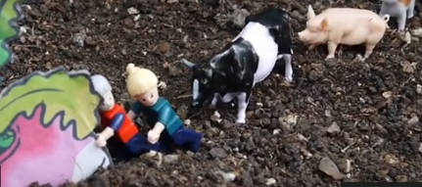

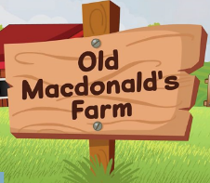

Maths: We have set you some challenges on Mathletics. There is a week to complete them, but do not worry if you don’t have time for them all. Use the log-in details we sent home.

**Shape!** Do you remember the shape pictures we sent home? Scroll down for more.

1. **3D shape hunt.** Watch Sarah’s video on Tapestry and then have a look around your home for 3D shapes. Tip – kitchen cupboards are a good place but ask an adult to help you. See if you can match them to the shape pictures and name them. Now hide an object behind your back and ask an adult to guess the 3D shape name.
2. **Find the faces** on your 3D shapes. What do you notice about them? What shapes are the faces of a cuboid? Try cutting along one edge of a cereal box to open it out flat and see the “net.” What about a cylinder? (A cylinder has 2 circle faces and one curved face which is an oblong – peel the label off a tin to prove it!)
3. If you have some paint, try **printing** with the different faces of your shape. Or draw around

each face on a piece of paper/decorate the faces of a 3D shape from your recycling.

1. **Build** with your 3D shapes (either toy construction or junk modelling). Which 3D shapes

were the most useful? Which were the hardest to join? Which balanced well?

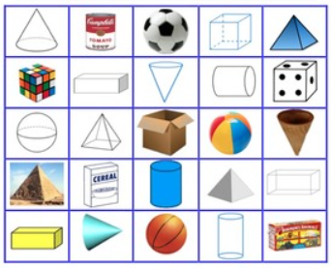

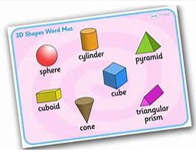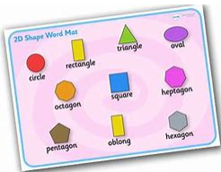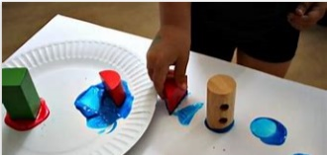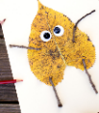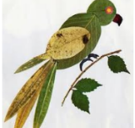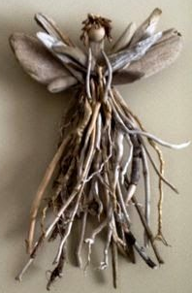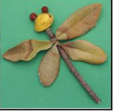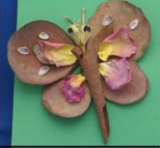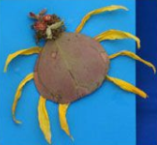

**Phonics**

qu qu-qu-qu-queen

Handwrite: Round her head, up past her earings and down past her hair

* [Geraldine Giraffe](https://www.google.com/search?q=geraldine+the+giraffe+qu&rlz=1C1GCEU_enGB894GB894&oq=geraldine+the+giraffe+qu&aqs=chrome..69i57j0l7.8992j0j7&sourceid=chrome&ie=UTF-8) 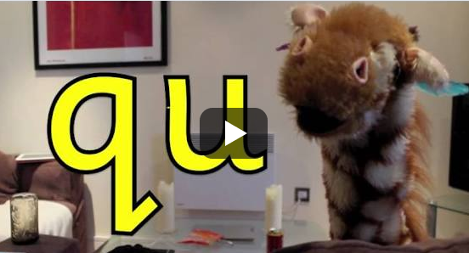

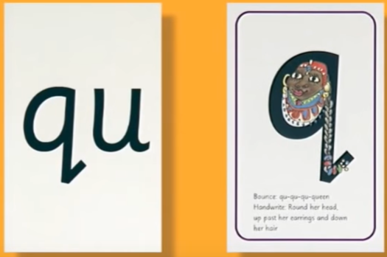

* Practise reading the qu sound in

Buzz comic on the next page

* Dictate these words for your child to write:

quiz quid quit

quick quack

* Finally dictate this sentence for them to write: The quick fox ran fast.

Don’t forget:

