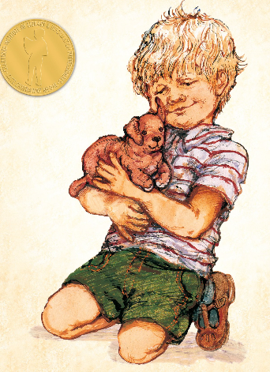
Year 1 Writing
Lesson 1
Monday 23rd March 2020
LO: To use capital letters and full stops.
In class we have been doing lots of work on using capital letters and full stops.
Read the text out loud with a grown up.
What is missing?
Can you put in the capital letters and full stops so that it makes sense?
Where else do you need to add capital letters?
Once you have finished copy it out in your best handwriting.

once there was a soft brown toy called dogger one of his ears pointed upwards and the other flopped over his fur was worn in places because he was quite old he belonged to dave dave loved dogger he took him everywhere sometimes he gave him a ride in his trolley sometimes he pulled him along on a lead made of string like a real dog when it was cold he wrapped him up in a bit of blanket

Remember a sentence must have a capital letter at the beginning and a full stop at the end. It must make sense on its own!
You must also use a capital letter for names.

Stepping Stone Activity
Read the sentences out loud.
Can you add capital letters and full stops?
Can you add a capital letter for any names?

once there was a soft brown toy called dogger
he belonged to dave
his fur was worn in places because he was quite old
dave loved dogger he took him everywhere

Now copy out the sentences in your best handwriting.

