Year 1 Writing
Lesson 10
Friday 3rd April 2020
LO: To recognise the prefix un
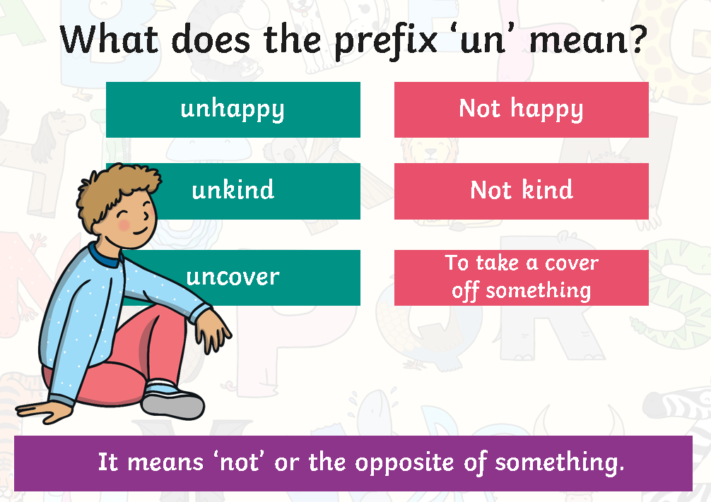

Can you think of more words that begin with the prefix un?
Write the word without and with the prefix.
What is the difference in the meaning?
Write a sentence using a word beginning with the prefix un.

Stepping Stones Activity
Copy and complete the sentences
