Year 1 Writing
Lesson 9
Thursday 2nd April 2020
LO: To use exclamation marks
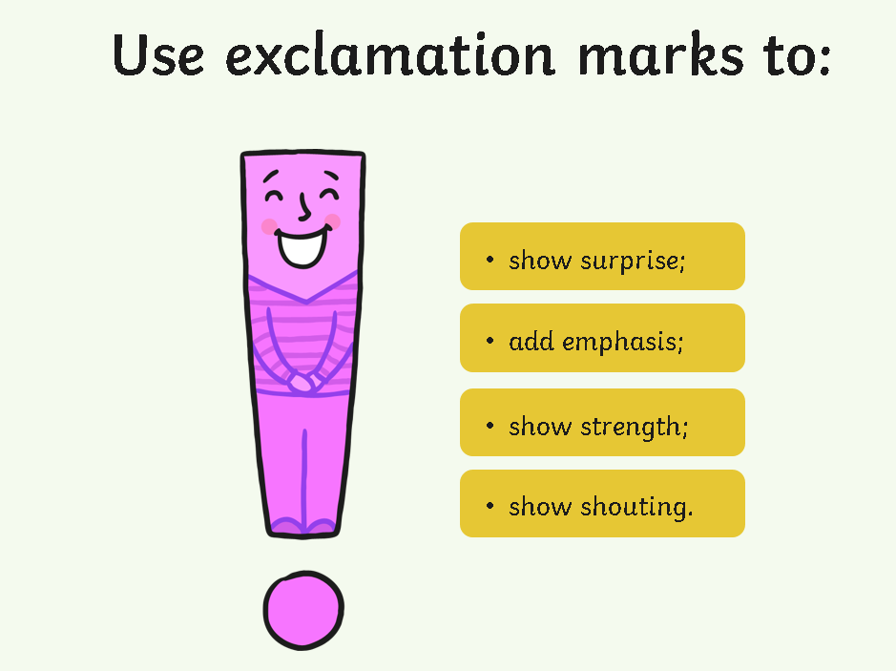

Read these sentences aloud.
Decide whether they need a full stop or an exclamation mark at the end of them.
Copy them out with using the right one at the end of each sentence.

Dogger belonged to Dave
I want Dogger back
Mum looked under the bed
The next day was the summer fair
There on the table was Dogger
Bella won first prize in the raffle
Bella got Dogger back for Dave

Stepping stones activity
Copy these sentences and add exclamation marks to them.
I want Dogger back
There on the table was Dogger
Bella won first prize in the raffle

