Answers from lesson 3 (subtract a single digit number)
Stepping stone activity
16 – 5 = 11
Main activity
Task 1 | Task 2
Own answers | 9 – 9 = 0
Task 3 | Task 4
Possible response: Tommy is correct because first there were 17 cakes and now there are still 17 cakes so zero cakes were eaten. | 20 – 9 = 11  19 – 8 = 11  18 – 7 = 11  17 – 6 = 11  16 – 5 = 11 etc.

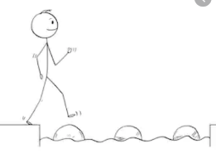
Year 1 Maths
Steppingstone activity
Lesson 3
LO: To subtract crossing 10
Steps to success:

- What number are you taking away? (5) Cross them out.
- How many will take you back to ten? (3) Show this as a jump of 3 on your number line.
- How many more do you need to take away? (2) Show this as a jump of 2 on your number line.
- How many are left? Write the calculation.
Model

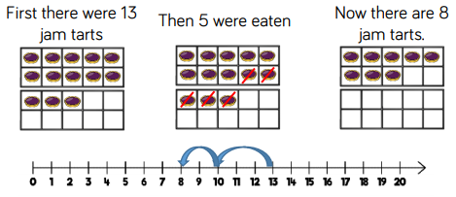

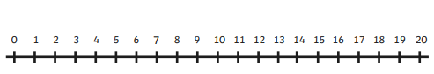
Year 1 Maths
Main activity
Complete at least 2 tasks, more if you can.
Task 1 | Task 2
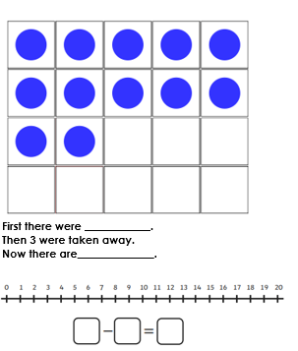 | 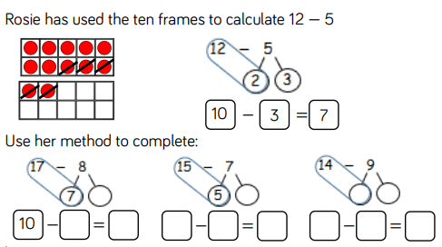

Task 3 | Task 4
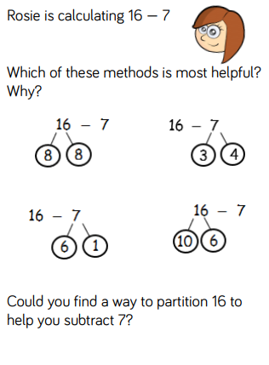 | 