Answers from lesson 4 (subtract crossing 10)
Stepping stone activity
13 – 5 = 8
Main activity
Task 1 | Task 2
12-3=9 | 10-1=9  10-2=8  10-5=5
Task 3 | Task 4
Partitioning the 7 into 6 and 1 is useful as Rosie can subtract the 6 to make 10 then subtract the 1.  If you partition 16 into 7 and 9, you can subtract 7. | 17 − 5 > 12 − 5  14 − 4 = 18 − 8  11 − 7 < 11 − 4

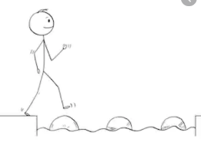
Year 1 Maths
Steppingstone activity
Lesson 5
LO: To understand the value of tens and ones in 2-digit numbers
Steps to success:

- Draw the dienes in the missing boxes.
- When you have finished you could cut out each box to make number cards.
- Muddle up the number cards then put them in order again.
- Hide a card – which one is missing?
Model

1 | 2 | 3 | 4 | 5 | 6 | 7 | 8 | 9 | 10
11 | 12 | 13 | 14 | 15 | 16 | 17 | 18 | 19 | 20

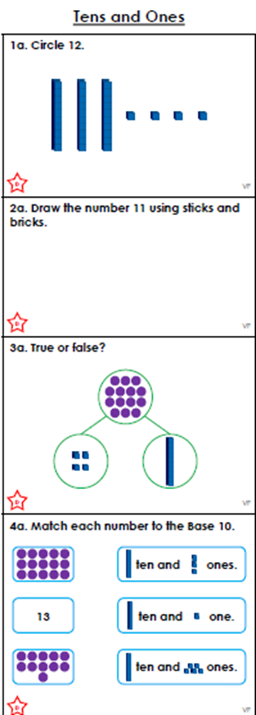
Year 1 Maths
Main activity Complete at least 2 tasks, more if you can.
Task 1 | Task 2 | Task 3 | Task 4
 | 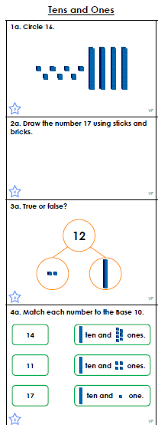 | 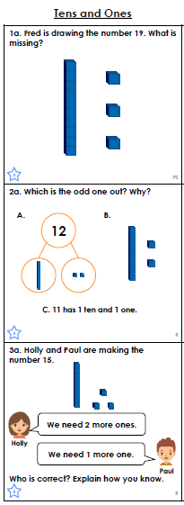 | 