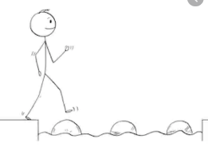
Year 1 Maths
Steppingstone activity
Lesson 6
LO: To count in 2s
Steps to success:

- Ask a grown up if you can use all the pairs of socks in the house!
- Pair them up and place them in a row.
- Make a counting in 2s number line.
- What pattern do you notice?
Model

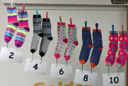
Fill in the missing numbers.
2 | 4 |  |  |  | 12 |  |  |  | 20
 |  | 26 |  |  |  | 34

Year 1 Maths
Main activity Complete at least 2 tasks, more if you can.
Task 1 | Task 2 | Task 3 | Task 4
How many shoes are there?  Count in 2s.  Try this with all the pairs of shoes at home.  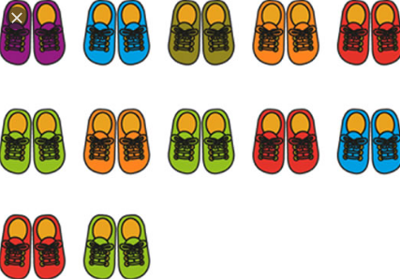  What else can we count in 2s? | Continue colouring the 2s on the grid.  What do you notice?  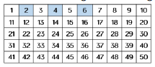 | 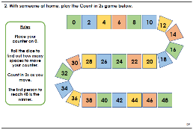  Scroll down for the larger version of this game | Scroll down to see this problem so solve about counting n 2s  