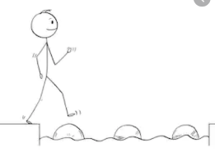
Year 1 Maths
Steppingstone activity
Lesson 7
LO: To count in 2s
Steps to success:
- Look around the house for pairs of objects to count in 2s.
- Pair them up.
- Count them in 2s.
Model
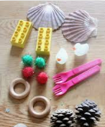

Fill in the missing numbers and colour in the ones you use to count in 2s from 0.
1 | 2 | 3 | 4
 |  |  |  | 15 |  |  |  |  | 20
 |  | 23 |  |  |  |  |  | 29
31 |  |  |  |  |  |  | 38

Year 1 Maths
Main activity Complete at least 2 tasks, more if you can.
Task 1 | Task 2 | Task 3 | Task 4
Draw pairs of objects and write the number under them:  Or print off these socks, colour them and fill in the missing numbers (scroll down for larger version):  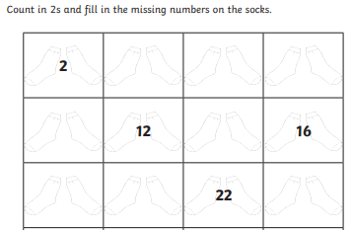 | Scroll down for the larger version of this game.  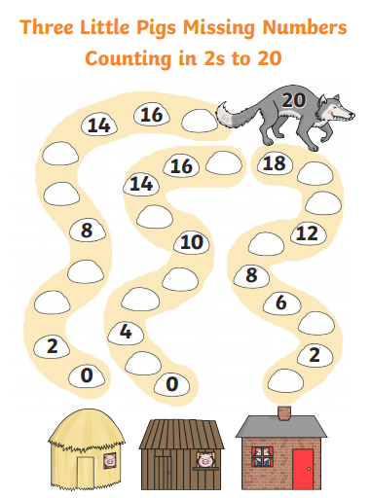 | Look at a 2p coin. Can you spot the number 2 on it? 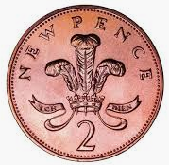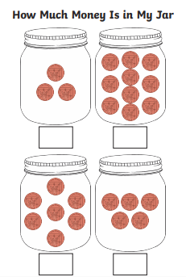 | 