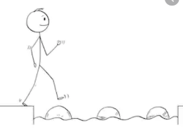
Year 2 Maths
Steppingstone activity
Lesson 5
LO: To count in multiples of 2, 5, and 10
Success Criteria:
- Practice counting in 2s, 5s, and 10s, using the times tables provided
- Answer the questions about equal groups in your book
1. How many wheels altogether?  2 + 2 + 2 + 2 + 2 = ____  ____ x 2 = ____ | 2. How many eyes altogether?  2 + 2 + 2 + 2 = ____  ____ x 2 = ____ | 3. How many fingers altogether?  5 + 5 + 5 = ____  ____ x 5 = _____
4. How many apples altogether?  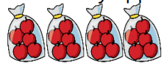  5 + 5 + 5 + 5 = ____  ____ x 5 = ____ | 5. How many fish altogether?  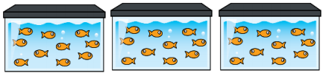  10 + 10 + 10 = ____  ____ x 10 = ____ | 6. How many paints altogether?  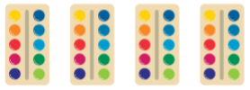  10 + 10 + 10 + 10 = ____  ____ x 10 = ____
Model:
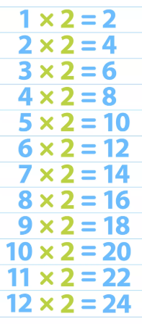

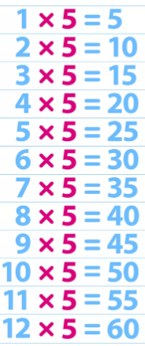

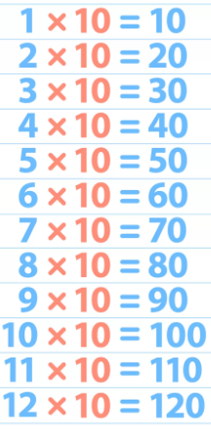

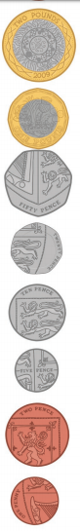
Year 2 Maths
Remember:
- 50p + 50p = 100p = £1
- Write the amounts before you circle them so that your numbers are clear
- Use facts you already know to help making the same amount easier (e.g. you know 2 ÷ 2 = 1 so would exchanging one £2 to two £1 coins help?)

Lesson 5
LO: To find different combinations of coins that equal the same amount of money
Task:
You are going to be using different coins to make the same amount
Success Criteria:
- Make the amount using the least amount of notes or coins (30p = 20p + 10p)
- Look at numbers you can change to make the next amount 20 ÷ 2 = 10 so two 10p coins can replace one 20p (30p = 10p + 10p + 10p)
- Look at numbers you can change to make the final amount 10 ÷ 2 = 5 so two 5p coins can replace one 10p (30p = 10p + 10p + 5p + 5p)
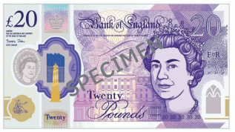
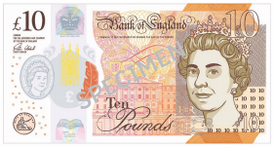
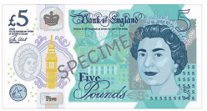

Model:
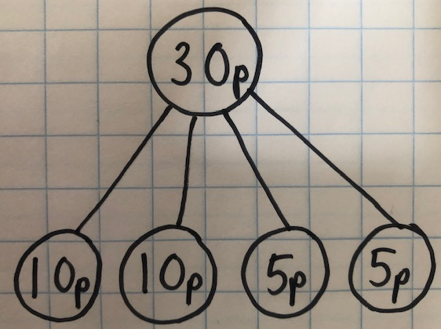
3.
2.
1.
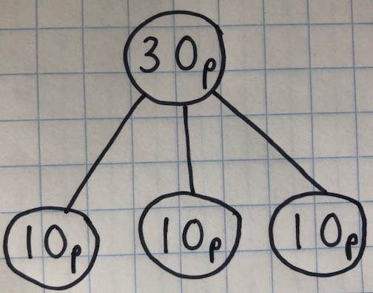
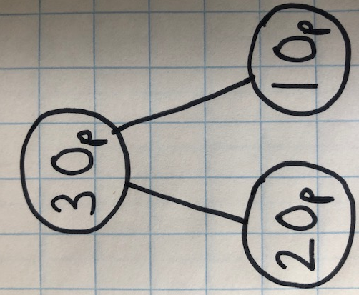

Year 2 Maths
Main activity
Complete at least 2 columns, more if you can!
Task 1 | Task 2 | Task 3 | Task 4
Practice  Can you find three different ways to make these amounts? Remember you must use real coins – no made up amounts in one ‘part’ e.g. 3p!  20p  45p  50p  £1 and 10p | Practice  Can you find three different ways to make these amounts? Remember you must use real notes and coins – no made up amounts in one ‘part’ e.g. £11!  £2 and 20p  £4 and 5p  £10 and 50p  £20 and 32p | Reasoning  Explain your answers.  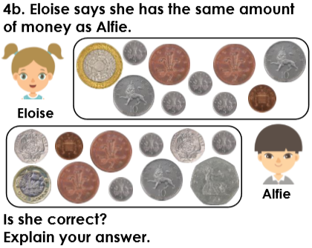  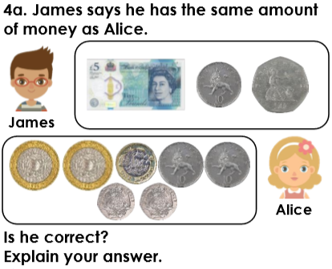 | 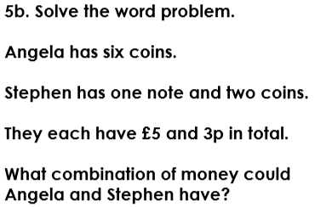  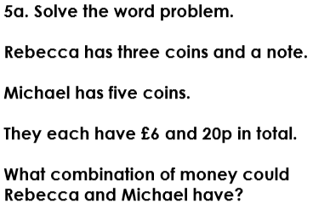  Problem solving

