Year 2 Maths day 3
ANSWERS
Task 1 | Task 2 | Task 3 | Task 4
Practice  Use a number line to add these 2-digit numbers:  17 + 16 = 33  27 + 14 = 41  34 + 17 = 51  38 + 25 = 63  42 + 29 = 71 | Practice  Use a number line to add these 2-digit numbers:  29 + 25 = 54  36 + 37 = 73  44 + 26 = 70  52 + 39 = 91  67 + 34 = 101  85 + 26 = 111 | Reasoning  Explain your answers. | 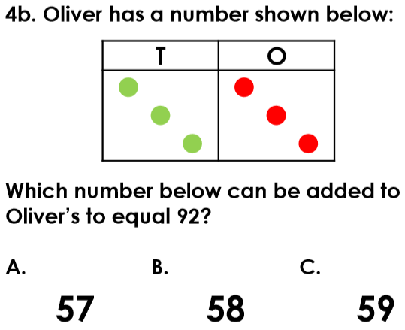  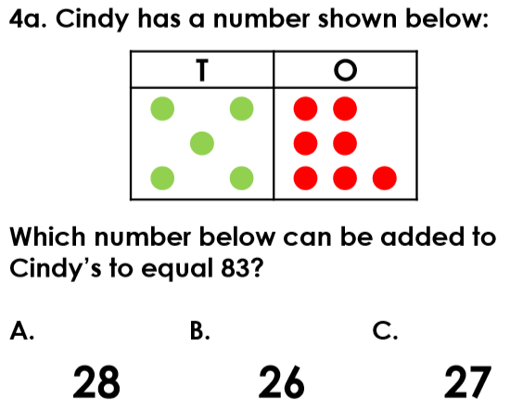  Problem solving

