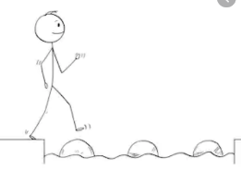
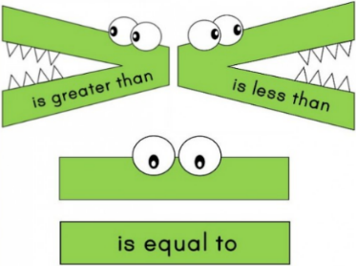
Year 2 Maths
Steppingstone activity
Lesson 4
LO: To compare numbers using greater than >, less than <, and equal to =
Success Criteria:
- Write the two numbers, leaving a space in the middle
- Use the greater than >, less than <, and equal to =, symbols to compare the two numbers
Model:
Your turn
1.

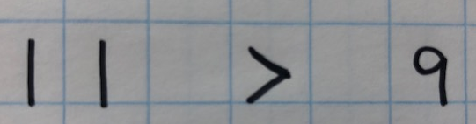
2.

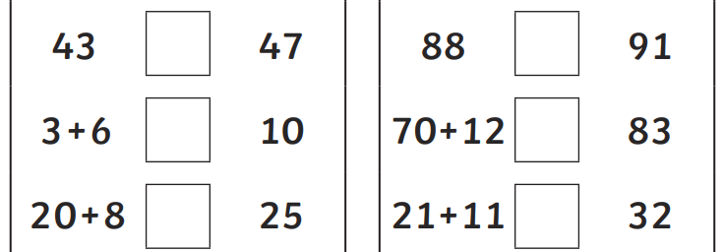
If you’d like to compare some more numbers or number sentences using the >, <, and =, symbols, here’s an extra challenge:

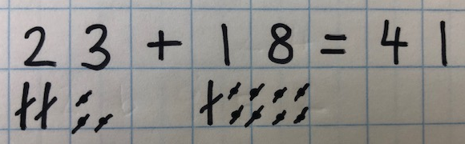
Year 2 Maths
Lesson 4
LO: To add two 2-digit numbers
Task:
You are going to be using Base 10 jottings for addition with exchange
Success Criteria:
- Write the number sentence (e.g. 23 + 18 =)
- Represent the numbers as tens and ones using Base 10 jottings
- Count the tens first, crossing off as you do
- Count the ones, continuing from your last ten (e.g. 10, 20, 30 – 31, 32…)
- Write the answer to complete your number sentence

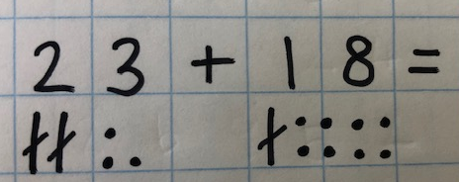
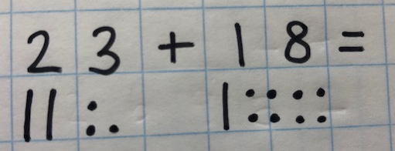
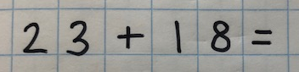
Model:
1.
3.
2.

5.
4.

Year 2 Maths
Main activity
Complete at least 2 columns, more if you can!
Task 1 | Task 2 | Task 3 | Task 4
Practice  Use Base 10 jottings to answer these calculations:  26 + 17 =  37 + 24 =  34 + 29 =  48 + 16 =  54 + 37 = | Practice  Use Base 10 jottings to answer these calculations:  39 + 22 =  32 + 48 =  54 + 39 =  52 + 31 + 18 =  50 + 36 + 35 =  55 + 26 + 61 = | Reasoning  Explain your answers.  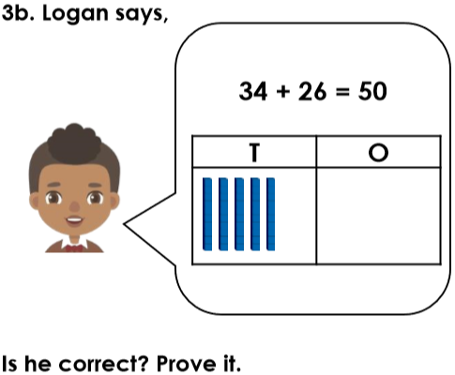  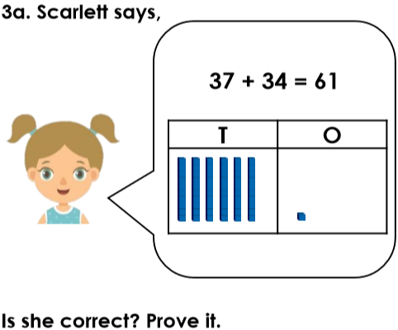 | 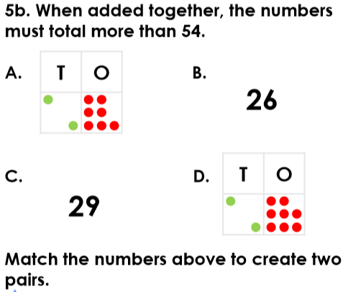  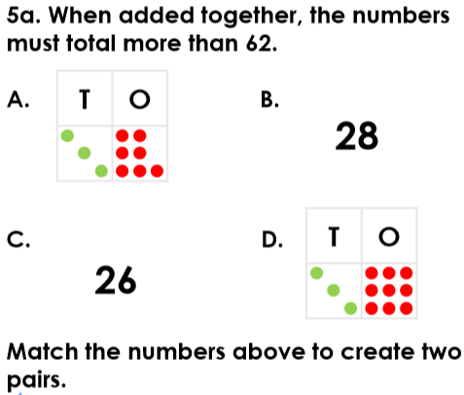  Problem solving

