Year 2 Maths
ANSWERS
Task 1 | Task 2 | Task 3 | Task 4
Practice  Use Base 10 jottings to answer these calculations:  36 - 17 = 19  43 - 14 = 29  45 - 16 = 29  54 - 29 = 25  61 - 35 = 26 | Practice  Use Base 10 jottings to answer these calculations:  32 - 19 = 13  37 - 18 = 19  54 - 25 = 29  71 - 36 = 35  112 - 36 - 15 = 61  132 - 28 - 24 = 80 | Reasoning  Explain your answers.  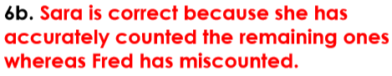 | 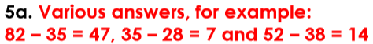  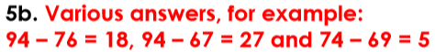  Problem solving

