Task 1 | Task 2 | Task 3
Practice  Use Base 10 jottings to help answer these word problems:  1. 15 - 3 = 12  12 - 4 = 8  2. 12 - 6 = 6  6 + 12 = 18  3. 23 - 6 = 17  17 - 8 = 9  4. 14 + 11 = 25  25 - 8 = 17 | Practice  Use Base 10 jottings to help answer these word problems:  5. 17 + 6 = 23  23 + 11 = 34  6. 20 - 8 = 12  12 - 7 = 5  7. 28 - 13 = 15  15 - 8 = 7  8. 26 - 12 = 14  14 - 5 = 9  9. 34 - 13 = 21  21 - 12 = 9 | Reasoning  “Now, for the cakes!”  One cake serves 16 people. Wilma is expecting between 30 and 40 guests.  “If I get 2 cakes that will be plenty!” she says.  Will she have enough cake?  16 + 16 = 32 so two cakes will only be enough for up to 32 people.  Wilma should get three cakes.  Explain your  answer.  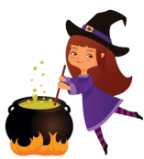
 |  | Task 4
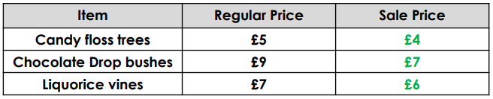
Problem solving
Wilma goes to Granny’s Garden Centre. She wants three big candy-floss trees, three chocolate drop bushes and three liquorice vines for her garden. Luckily, Granny is having a sale!

Candy floss trees: £12 (£4 + £4 + £4) Chocolate Drop bushes: £21 (£7 + £7 + £7) Liquorice vines: £18 (£6 + £6 + £6)
Year 2 Maths
ANSWERS

