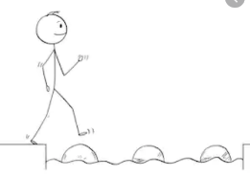
Year 2 Maths
Steppingstone activity
Lesson 2
LO: To count in 5s
Success Criteria:
- Practice counting in 5s, using the five times table provided
- Answer the questions in your book
1. Count the Numicon pieces in 5s.  What is the total of the Numicon?  If you can, write the multiplication sentence:  ____ x 5 = ____ | 2. Count the dice in 5s.  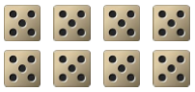  What is the total of the dice?  If you can, write the multiplication sentence:  ____ x 5 = ____ | 3. Ted has put pom-poms into jars:  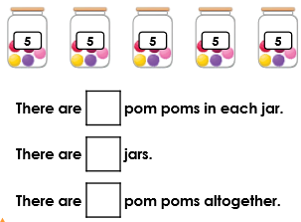
4. Freya has put plums into bowls:  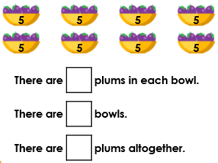 | 5. Answer the five times table questions:  1 x 5 =  2 x 5 =  3 x 5 =  4 x 5 =  5 x 5 =  6 x 5 = | 6. Answer the five times table questions:  7 x 5 =  8 x 5 =  9 x 5 =  10 x 5 =  11 x 5 =  12 x 5 =
Model:
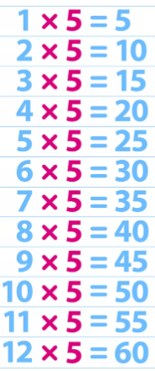

Year 2 Maths
Lesson 2
LO: To solve two-step addition and subtraction word problems
Task:
You are going to be using Base 10 jottings to help solve addition and subtraction word problems
Success Criteria:
- Read the question carefully and identify the first operation (+ or -)
- Write the first number sentence using Base 10 jottings to check your answer
- Reread the question carefully to identify the second operation (+ or -)
- Write the second number sentence using Base 10 jottings to check your answer

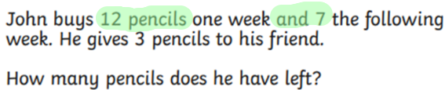
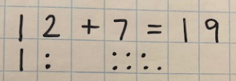
Model:
2.
1.

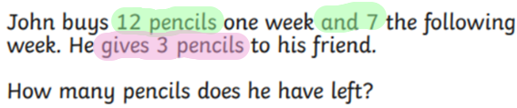
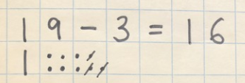
3.
4.

Task 1 | Task 2 | Task 3
Practice  Use Base 10 jottings to help answer these word problems:  1. Lydia has 15 marbles. She takes them to her friend’s house.  She loses 3 on the way and 4 in the house. How many does she have left?  2. Asif has a packet of 12 biscuits. He gives 6 of the biscuits to some friends. He buys another packet of 12 biscuits. How many biscuits does he have now?  3. Amina collects 23 conkers. She gives 6 conkers to her brother and 8 to her sister. How many conkers does she have left?  4. James and Zain bring their football cards to share with their friend Tom. James brings 14 and Zain brings 11. They give Tom 8 cards between them. How many cards do they have left altogether? | Practice  Use Base 10 jottings to help answer these word problems:  5. Amy has a box of apples. She sells 17 in the morning. She sells 6 in the afternoon. There are 11 apples left. How many apples were there at the start of the day?  6. A cook has 20 pie trays. She uses 8 trays for meat pies and 7 trays for vegetarian pies. How many trays are not used?  7. A PE teacher has 28 balls. There are 13 blue balls and 8 green balls. How many red balls are there?  8. A farmer has 26 cows, which he keeps in 3 fields. He counts 12 cows in the first field and 5 in the second. How many cows are in the third field?  9. Jen takes 34 photos in a day. She takes 13 in the morning and 12 in the afternoon. How many photos does she take in the evening? | Reasoning  “Now, for the cakes!”  One cake serves 16 people. Wilma is expecting between 30 and 40 guests.  “If I get 2 cakes that will be plenty!” she says.  Will she have enough cake?  Explain why.  Explain your  answer.
 |  | Task 4
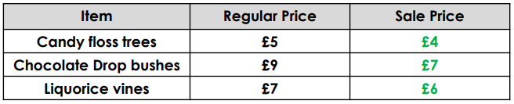
Problem solving
Wilma goes to Granny’s Garden Centre. She wants three big candy-floss trees, three chocolate drop bushes and three liquorice vines for her garden. Luckily, Granny is having a sale!

How much does Wilma spend on each type of plant?
Year 2 Maths
Main activity
Complete at least 2 columns, more if you can!

