Year 2 Maths
ANSWERS
Task 1 | Task 2 | Task 3 | Task 4
Practice  Use Base 10 jottings to answer these calculations:  100 - 85 = 15  85 + 15 = 100  100 - 74 = 26  74 + 26 = 100  100 - 63 = 37  63 + 37 = 100  100 - 52 = 48  52 + 48 = 100  100 - 21 = 79  21 + 79 = 100 | Practice  Use Base 10 jottings to answer these calculations:  100 - 16 = 84  16 + 84 = 100  100 - 32 = 68  68 + 32 = 100  100 - 17 = 83  83 + 17 = 100  100 - 32 - 7 = 61  32 + 61 + 7 = 100  100 - 23 - 15 = 62  23 + 62 + 15 = 100 | Reasoning  Explain your answers.  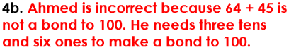 | 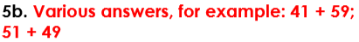  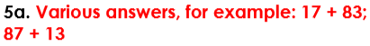  Problem solving

