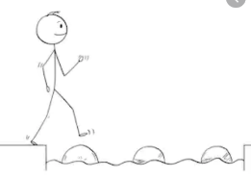
Year 2 Maths
Steppingstone activity
Lesson 3
LO: To count in 10s
Success Criteria:
- Practice counting in 10s, using the ten times table provided
- Answer the questions in your book
1. If one domino has 10 spots, how many spots do 4 dominoes have?  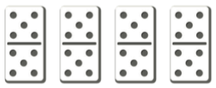  If you can, write the multiplication sentence:  ____ x 10 = ____ | 2. If one packet of seeds has 10 seeds, how many seeds do 9 packets of seeds have?  If you can, write the multiplication sentence:  ____ x 10 = ____ | 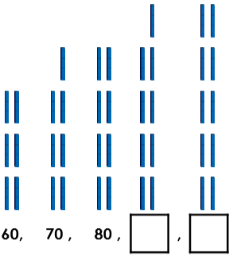  3. Complete the sequence to find the missing numbers:
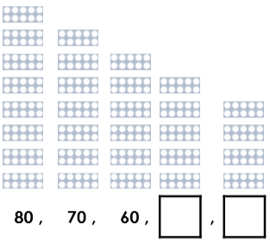  4. Complete the sequence to find the missing numbers: | 5. Answer the ten times table questions:  1 x 10 =  2 x 10 =  3 x 10 =  4 x 10 =  5 x 10 =  6 x 10 = | 6. Answer the ten times table questions:  7 x 10 =  8 x 10 =  9 x 10 =  10 x 10 =  11 x 10 =  12 x 10 =
Model:
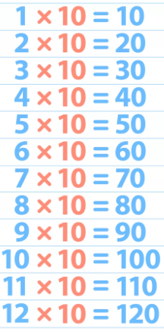

Year 2 Maths
Lesson 3
LO: To recognise and use the inverse relationship between addition and subtraction and use this to check calculations and missing number problems
Task:
You are going to be using the inverse and Base 10 jottings to make number bonds to 100
Success Criteria:
- Write the number sentence as a subtraction (e.g. 33 + ____ = 100 would be 100 - 33 = ____)
- Represent 100 using Base 10 jottings (you do not need to draw the second number!)
- Exchange one of the tens for ten ones
- Cross off the amount you are subtracting
- Count together the remaining tens and ones, then write the answer to complete your number sentence
- Check your answer using the inverse, by representing the addition number sentence

Model:
2.
3.
1.
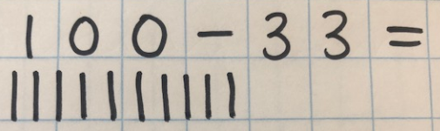
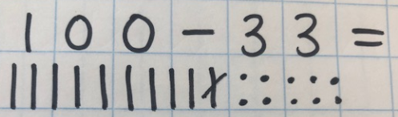
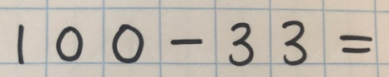

6.
5.
4.
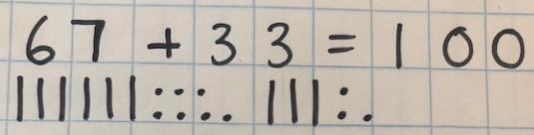
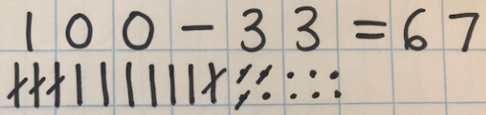
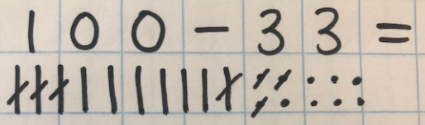

Year 2 Maths
Main activity
Complete at least 2 columns, more if you can!
Task 1 | Task 2 | Task 3 | Task 4
Practice  Use Base 10 jottings to answer these calculations:  85 + ____ = 100  74 + ____ = 100  63 + ____ = 100  52 + ____ = 100  21 + ____ = 100 | Practice  Use Base 10 jottings to answer these calculations:  16 + ____ = 100  ____ + 32 = 100  ____ + 17 = 100  32 + ____ + 7 = 100  23 + ____ + 15 = 100 | Reasoning  Explain your answers.  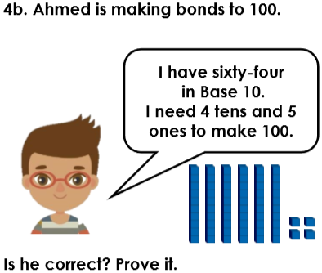  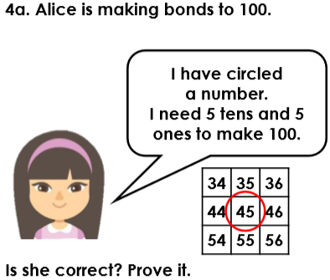 | 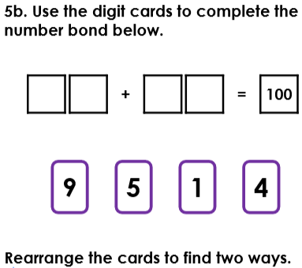  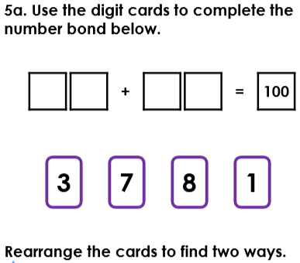  Problem solving

