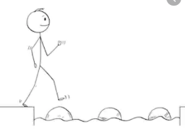
Year 2 Maths
Steppingstone activity
Lesson 4
LO: To count in multiples of 2, 5, and 10
Success Criteria:
- Practice counting in 2s, 5s, and 10s, using the times tables provided
- Answer the questions in your book
1. Spot the multiples of 2 (numbers in the 2 times table) and write them in your book.  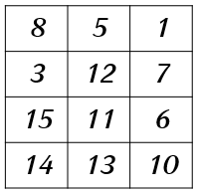 | 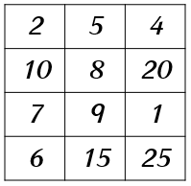  2. Spot the multiples of 5 (numbers in the 5 times table) and write them in your book. | 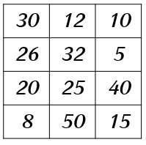  3. Spot the multiples of 10 (numbers in the 10 times table) and write them in your book.
4. Make 4 equal groups with 2 flowers in each group:  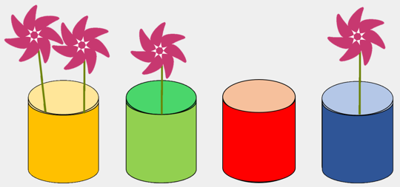  Can you write a multiplication sentence for your equal groups?  ____ x 2 = ____ | 5. Make 3 equal groups with 5 stars in each group:  Can you write a multiplication sentence for your equal groups?  ____ x 5 = ____ | 6. Make 2 equal groups with 10 pencils in each group:  Can you write a multiplication sentence for your equal groups?  ____ x 10 = ____
Model:
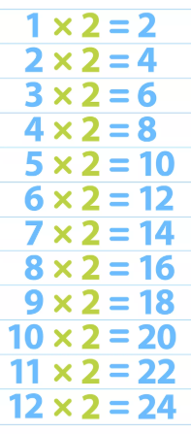

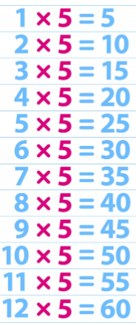

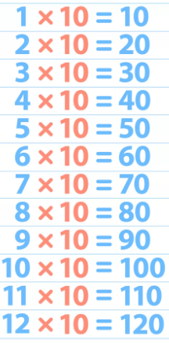

Year 2 Maths
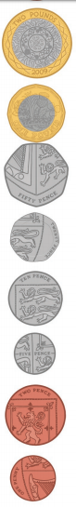
Lesson 4
LO: To recognise and use symbols for pounds (£) and pence (p)
Task:
You are going to be counting money by adding together £ and p
Success Criteria:
- Look carefully at the amount shown, taking time to identify the different notes and coins
- Identify the pounds (£ - remember these can be notes and coins!) first and add them together, use Base 10 jottings if they help
- Identify the pence (p) and add them together, use Base 10 jottings if they help
- Write your total as £____ and ____p
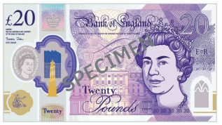
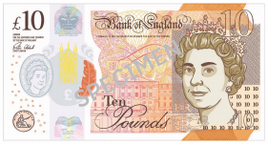
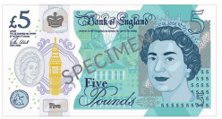

Model:
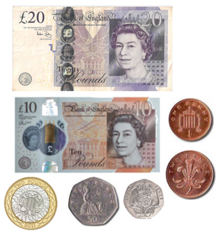
1.
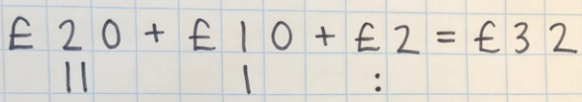
2.

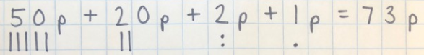
3.

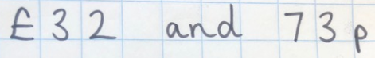
4.

Task 1 | Task 2 | Task 3
Practice  How much money is shown? Remember to write your answers as £____ and ____p!  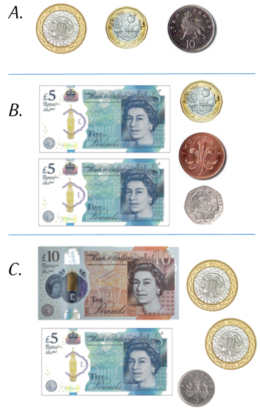 | Practice  How much money is shown?  Remember to write your answers as  £____ and ____p!  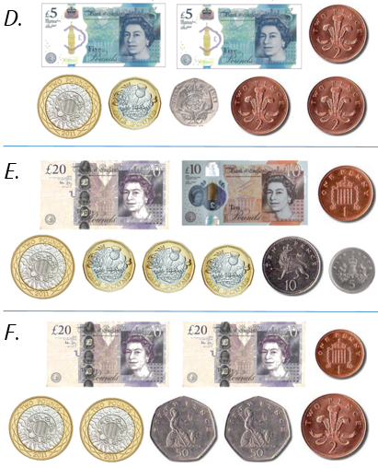 | Reasoning  Explain your answer.  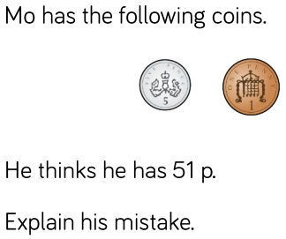
 |  | Task 4
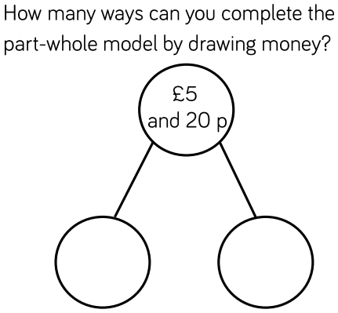
Problem
solving

Year 2 Maths
Main activity
Complete at least 2 columns, more if you can!

