Task 1 | Task 2 | Task 3
Practice  How much money is shown? Remember to write your answers as £____ and ____p!  - £3 and 10p  - £11 and 22p  - £19 and 5p | Practice  How much money is shown?  Remember to write your answers as  £____ and ____p!  - £13 and 26p  - £35 and 16p  - £45 and 3p | 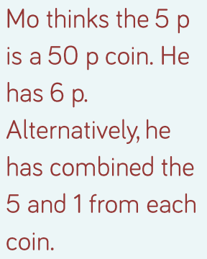  Reasoning  Explain your  answer.
 |  | Task 4
Problem solving
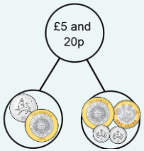
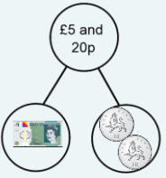
Example answers:
Year 2 Maths
ANSWERS

