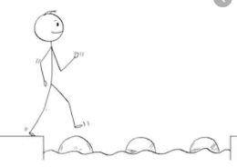
Year 2 Reading
Steppingstone activity
Date: Friday 3rd April 2020
LO: To retrieve information
Reading Skill: Retrieval
Success Criteria:
- Look at the picture carefully.
- Answer the questions in your books.
- Read your answers back to check they make sense.

- What colour is the toy box?
- Who is sat on the mat?
- What colour is Zack’s hair?
- What toy is Jen playing with?
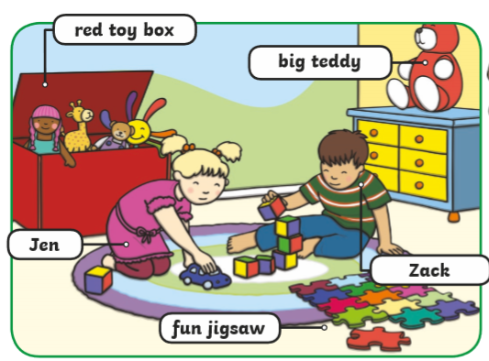

Challenge: Write a sentence to describe what each child is doing in the picture.
Jen is _________________________________________.
Zack is ________________________________________.

Year 2 Reading
Date: Friday 3rd April 2020
LO: To retrieve information from a text
Reading Skill: Retrieval
Success Criteria:
1. Read the text.
2. Read each question.
3. Find the information in the text.
4. Write your answers and read them back to check they make sense.
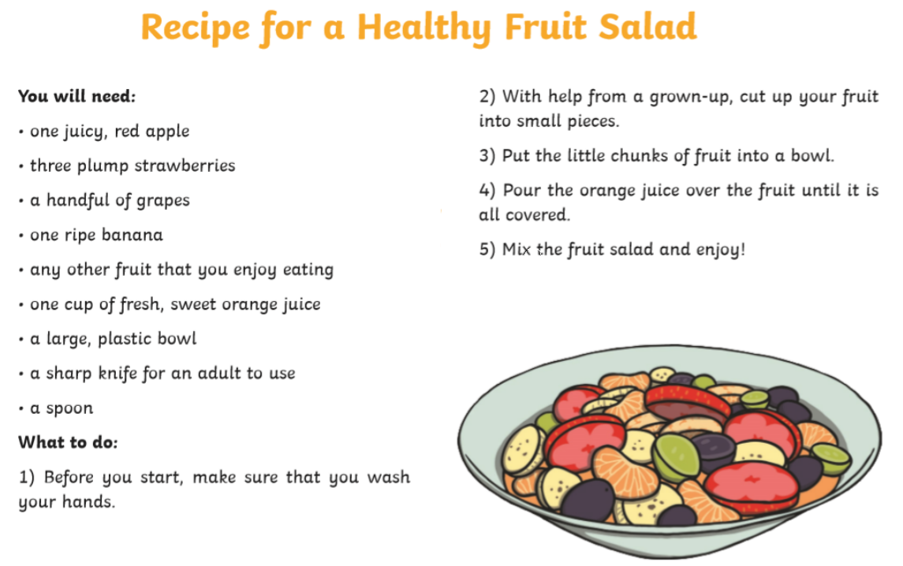

Questions:
- What should you do before you start preparing the food?
- Who can help you cut up your fruit?
- Which two adjectives does the author use to describe the orange juice?
- How many types of different fruit are in this recipe? Can you name them?
- How many plump strawberries would you need for this recipe?
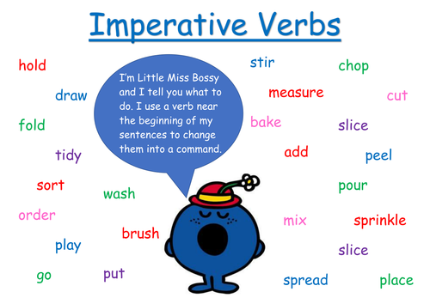
SPAG Retrieval Challenge:
Can you retrieve the bossy verbs from the text?

