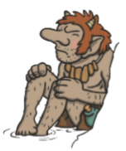
Year 2 Reading
Text:
Troll’s Troubles
Dear diary, I love my little house underneath the bridge in the valley but I get very grumpy when I hear grubby, little goats trotting over the top of it when I am trying to sleep.

One morning, three goat brothers made a plan to cross my bridge; they knew it would make me cross.

One at a time, they bashed their hooves across the bridge. When I went outside to tell them to be quiet, the biggest goat pushed me with his horns and I fell off the bridge into the river. I was furious!
I think I’m going to move house.
Dave the Troll

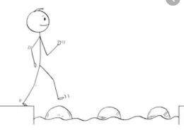
Year 2 Reading
Steppingstone activity
Date: Thursday 26th March 2020
LO: To make inferences based on images
Reading Skill: Inference
Success Criteria:
- Look at the picture- How do you think the troll feels?
- Draw the picture
- Label your drawing with words for feelings of the troll

Year 2 Reading
Date: Thursday 26th March 2020
LO: To retrieve information from a text
Reading Skill: Retrieval

Success Criteria:
1. Read the text
2. Read each question
3. Find the information in the text
4.Write your answers to each question in your exercise book

- Why does the troll get grumpy when people cross the bridge?

- Where does the troll live?

- How many goat brothers were there?

- When the troll went outside to tell the goats to be quiet, what did they do?

Challenge: SPAG Question
Find and copy two adjectives in the text which mean the same as ‘angry’.

