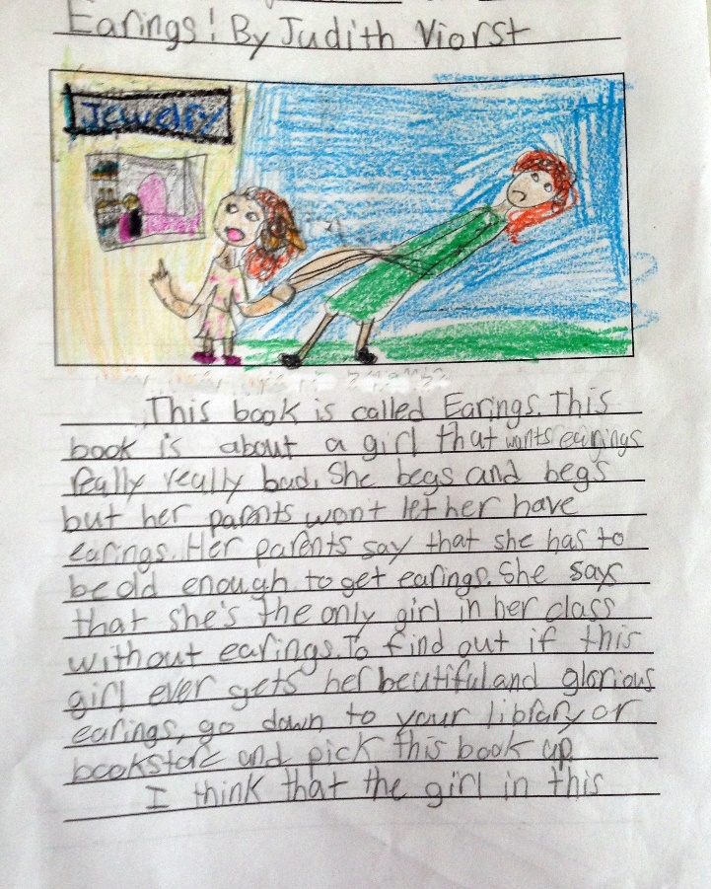
Year 2 Reading
Date: Tuesday 31st March 2020
LO: To express opinions about books
We hope you are enjoying reading for pleasure.
To be a fantastic reader in Year 2, we must be able to talk about the books we have read and express our opinions on them.
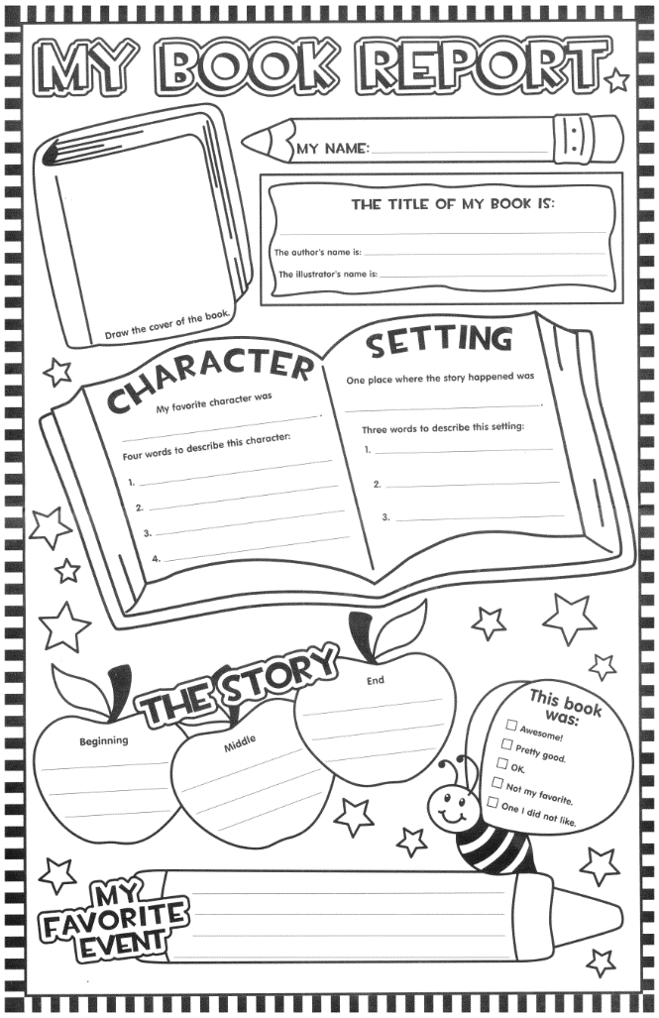
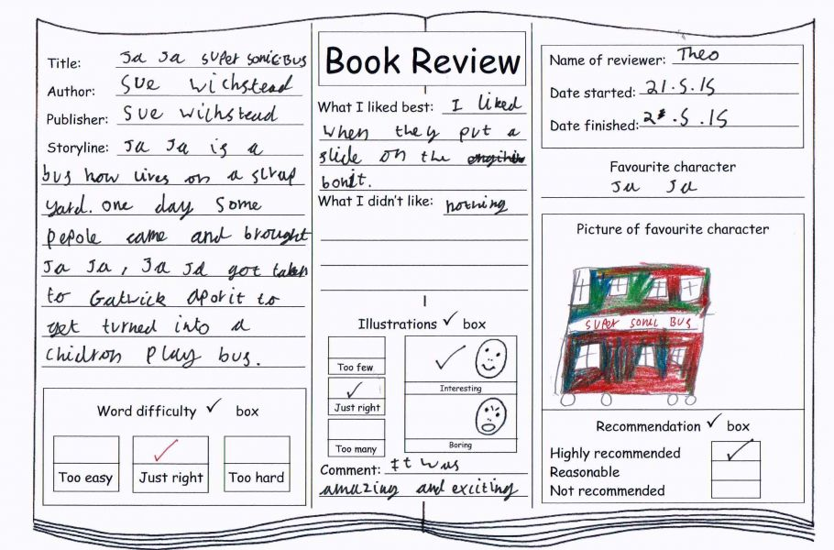
Take a look at these book review ideas to help you make your own!

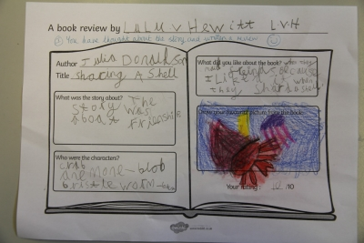

Year 2 Reading
Date: Tuesday 31st March 2020
LO: To express opinions about books
Success Criteria:
- Choose a book from home or school to explore and read. (This could be the book you chose yesterday)
- In your exercise book, write a book review on the book (look at the format below for ideas to include). If your book is non-fiction, you could write down the new facts you have learnt!

Remember- Take a good look at the book reviews above for some inspiration and ideas.
After you have done your writing, you could decorate your book review in your books to make it as colourful and exciting as possible!
