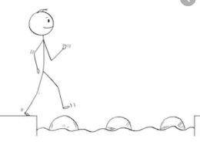
Year 2 Reading
Steppingstone activity
Questions:
- Write one thing a dog needs.
- What is a baby dog called?
- What do dogs need to stay safe on a walk?
- Why do dogs need to run a lot?

Skill: Retrieval
Date: Wednesday 1st April 2020
LO: To retrieve information from a text
Success Criteria:
- Look at the reading comprehension.
- Read each question.
- Find your answers in the text and write your answers in your book.
Challenge: Create your own information poster about taking care of a dog!
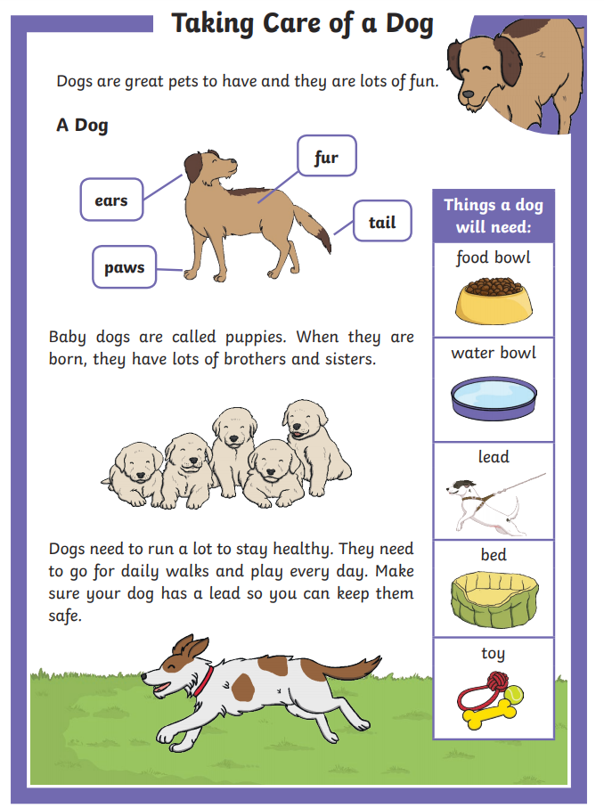
You can look at the red outlined clues to help you find the answers to these questions!

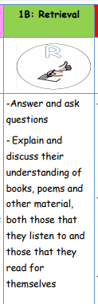
Year 2 Reading
Date: Wednesday 1st April 2020
LO: To retrieve information from a text
Skill: Retrieval
Success Criteria:
1. Read the text.
2. Read the questions.
3. Use the text to find your answers and write your answers as full sentences, neatly in your exercise books.
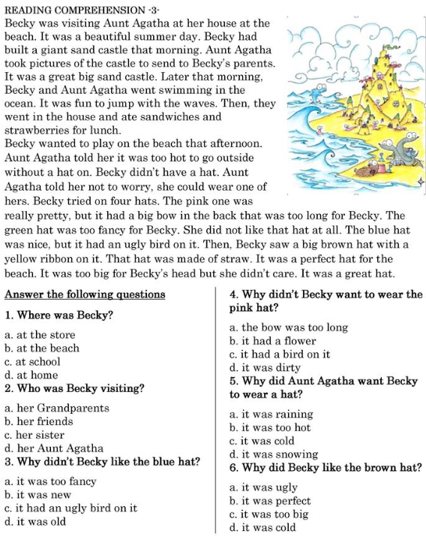
EG: 1. Becky was at the beach.
Retrieval challenge questions:
7. In the opening paragraph, what adjective did the author use to describe the day?
8. Draw a picture of Becky’s sandcastle based on the author’s description.
9. What did Becky and Aunt Agatha do in the ocean?
10. Which two items of food did Becky and Aunt Agatha have for lunch? Draw them!

