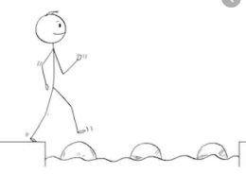
Year 2 Reading
Steppingstone activity
Date: Thursday 2nd April 2020
LO: To make inferences based on images
Reading Skill: Inference
Success Criteria:
- Carefully look at the picture below.
- Draw the picture in your books.
- Write a sentence about what you think is happening in this picture.
- Label the characters with their feelings.

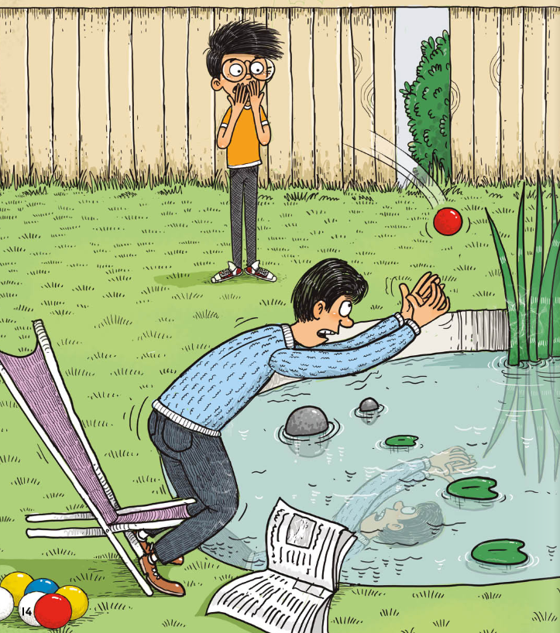

Challenge questions:
- How do these characters know each other?

- Who threw the ball?

- What do you think will happen to the man?

Year 2 Reading
Date: Thursday 2nd April 2020
LO: To make inferences based on images
Reading Skill: Inference
Success Criteria:
- Look at the picture.
- Read each question and think about the answer and your reason WHY you think this. You must find evidence based on what you can see or what you know from the picture.
- Write your answers in your books, giving clear reasons why you have made your inferences using ‘because’.
- Read your answers back to check they make sense.

You can start your sentence with I think or I infer.
EG: I infer the child is in the bath because she is wet and she has shampoo in her hair.
(Here, I have not read anything about the child or seen a bath but I have used my inference detective skills to find clues like the shampoo in the child’s hair. These clues are evidence that help me gives reasons for my thinking.)
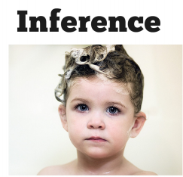

- What is happening in this picture and why do you think this?

- How does the child feel about what is happening and why do you think this?

- Where are these children and why do you think this?

- What are they doing and how do you know this?

- Do these children know each other? Why do you think this?
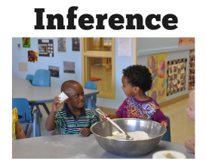

Challenge: Answer the two questions below the picture using your inference skills.

You may already know what is happening in this picture from your own experiences!
This means you will have lots of evidence to give reasons WHY you think what you think.
Remember to use the conjunction because to give your reasons.
