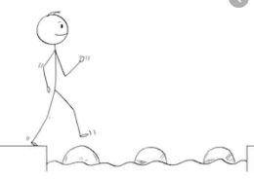
Year 2 Science Living Things and Their Habitats
Summer 1 Week 1
Stepping Stone Activity
W/C 20th April 2020
LO: To classify objects as those that are living, dead and those that have never been alive.
https://www.bbc.co.uk/bitesize/topics/z6882hv/articles/zs73r82
Success Criteria:
- Click the link above and watch the video.
- Draw a simple table with 3 headings (copy the table on the page below)
1. Living, 2. Dead, 3. Never Alive.
- Draw pictures of the objects below that are living, dead or never alive in the correct category on your table.

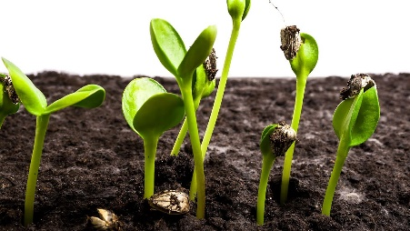
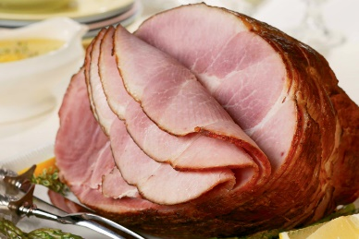
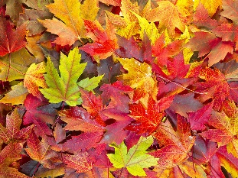

Challenge: Can you draw and label 1 thing that is living, 1 thing that is dead and 1 thing that has never been alive?
These must be your own ideas. You could have a look around your house or outside to help with ideas.

Year 2 Science Living Things and Their Habitats
Summer 1 Week 1
W/C 20th April 2020
LO: To classify objects as those that are living, dead and those that have never been alive.
https://www.bbc.co.uk/bitesize/topics/z6882hv/articles/zs73r82
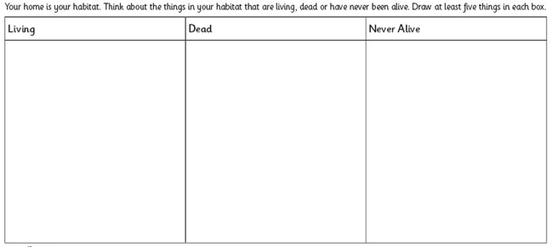
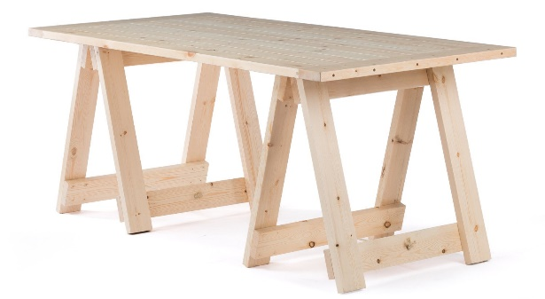
Success Criteria:
Challenge- write a sentence to describe which category this object would fall under giving reasons why.
Clue- think about the material it is made from!
- Click the link above and watch the video.
- Complete the table below (take a look at the Stepping Stone activity for examples).

