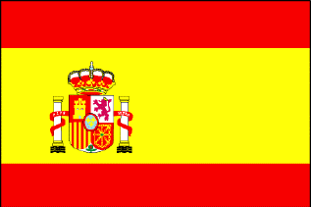
Year 2 Spanish

Summer 1: Week 3  Year 2  Spanish Online Home Learning | Year 2  Hola Dear Year 2! ¿Como estas? I hope you are all well. Me and my family are keeping well too.  This week we are going to recap I like/ Me gusta in Spanish.  Start by watching the clip and repeat in Spanish different foods.  Think of the fruit or vegetable you like the most…  For example Me gusta la naranja/ I like oranges, ¿Y tu? And you?  Watch this clip https://www.youtube.com/watch?v=iXaEw449H-Q  Activity: Draw a picture of what food you like the most and write below ME GUSTA… (I like…)  Story time in Spanish  https://www.bbc.co.uk/bitesize/clips/zr2kjxs  Clara lives with her stepmother and stepsister who treat her terribly. She cooks and cleans all day with little thanks. One day she drops something down the well and her stepmother throws her down the well to retrieve it. Instead she meets Frau Holle who invites her to stay in her house. When it's time to leave, Frau Holle gives her a fabulous golden dress. When the stepmother sees this, she decides to send her other daughter, Agnes, to see Frau Holle. Will she also get a golden dress for her efforts? Do you know a story where there is a stepmother and stepsister?

