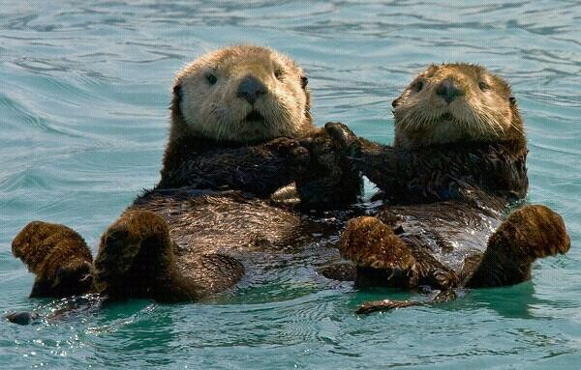
Year 2 Writing
Lesson 5
Friday 3rd April 2020
LO: To use adjectives to describe
Hello and Happy Friday Athena and Odysseus!
Today you are thinking about using adjectives to describe. To do this, you will be creating your own monster characters. If you are finding it tricky, you can think of yesterday’s video clip for ideas or you can create a completely different monster! Remember- powerful adjectives help create detailed descriptions and this makes our writing more exciting- Have fun!
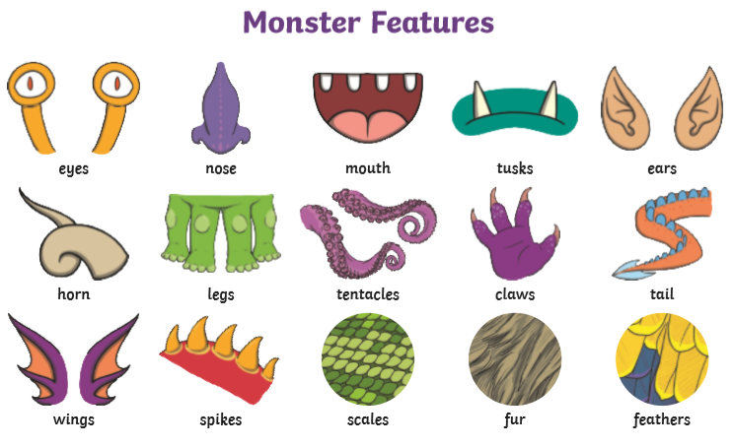

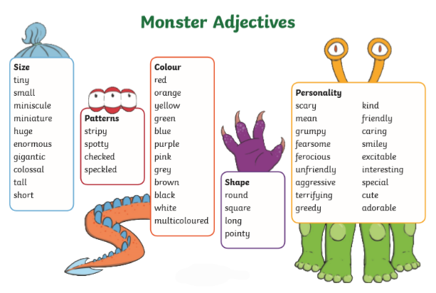

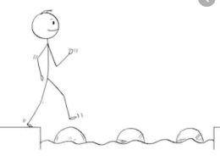
Year 2 Writing
Lesson 5 Steppingstone activity
Friday 3rd April 2020
LO: To use adjectives to describe
Success Criteria:
- Draw your own monster character and colour it in.
- Label your character with adjectives and nouns (EG: Sharp claws).

Adjectives | Nouns
big  green  yellow  sharp  scared  shocked | monster  teeth  claws  eyes  ears
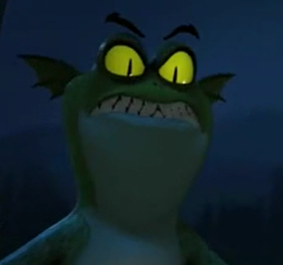

Challenge: Write at least two sentences about your monster character using your adjectives to describe.

Year 2 Writing
Lesson 5
Friday 3rd April 2020
LO: To use adjectives to describe
Success Criteria:
- Design and draw your own monster character and colour it in neatly.
- Label your character with nouns and adjectives (EG: long, sharp claws).
- Write a character description for your monster using the adjectives you labelled it with- try to include as much detail as possible for the reader to really imagine your character in their minds as they read!
- Answer the questions below.

EG: My monster has slimy green skin and sharp prickles running down his back. His wide eyes can be seen glowing brightly in the dark and this magical glow helps him guide the way home when he gets lost in the dark forest…
Adjectives | Nouns
large  green  yellow  sharp  prickly  slimy  rough  scaly | monster  teeth  claws  eyes  ears  tongue  back  feet

Use the word mats on page one to help you think about the different features you could describe.

- What is your monster’s name?
- What is your monster’s favourite colour?
- What does your monster’s voice sound like?
- Where does your monster live?
- What does your monster do for fun?

Challenge: Design and label your character’s home. If you’re feeling confident, go ahead and write a setting description, including details about where they live and what it’s like!

