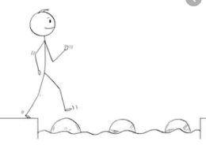
Year 2 Writing
Lesson 4 Steppingstone activity
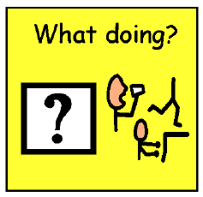

verb
swinging
eating
laughing
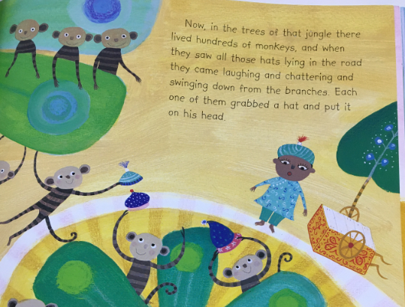
Thursday 26th March 2020
LO: To use verbs

The monkeys were

Success Criteria:
- Read the sentences using each verb
- Write the sentences using each verb
- Draw a picture of the monkeys for each sentence

Challenge: Use an adjective and add more detail too!
EG: The cheeky monkeys were swinging in the tree.

Year 2 Writing
Lesson 4
Thursday 26th March 2020
LO: To use verbs

Success Criteria:
- Read the sentences
- Write the sentences and underline the verbs in them
- Re-write the sentences again and up-level your work by choosing new, improved verbs
- Draw pictures for your sentences

Challenge: Include adverbs to make your writing more exciting!

EG: When the monkeys saw all those hats, they looped round the branches of the trees and sprinted towards them, chuckling and laughing loud

