Hello and Happy Tuesday Athena and Odysseus!

We hope you’re well and enjoying your home learning!

This poster will help you understand today’s learning.
You are continuing with yesterday’s learning and are thinking about using different sentence types.

This is an important learning point on our Year 2 Writing Checklist!

Remember – You should do what you feel confident with.
If you just want to complete the Stepping Stone activity, that’s fine!
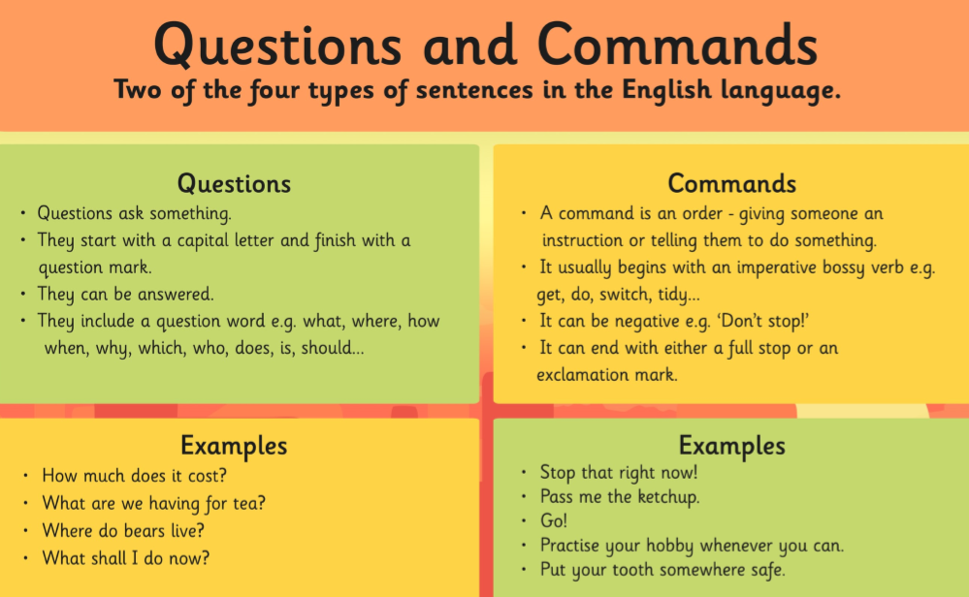
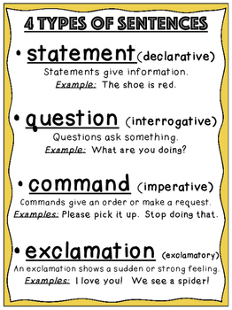
If you feel confident enough, go straight to the main activity!
Tuesday 31st March 2020
LO: To identify and use different sentence types
Starter activity- the difference between statements and commands
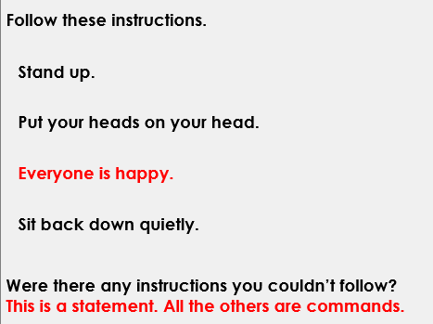
After you have followed the instructions, move the red box to show the answer!

Reasoning
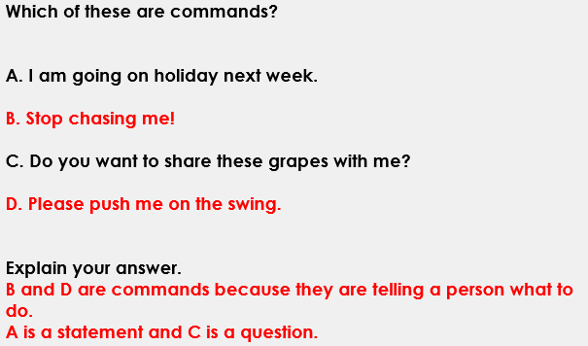

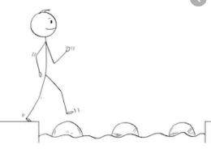
Year 2 Writing
Lesson 2 Steppingstone activity
Tuesday 31st March 2020
LO: To use full stops, question marks and exclamation marks
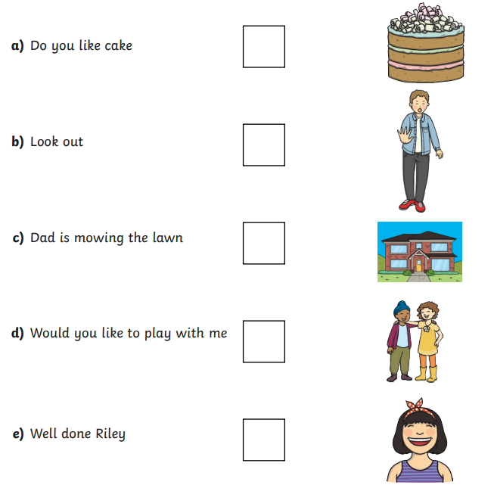
Success Criteria:
- Read the sentences.
- Is it a question, command or statement?
- Write out your sentences and use ? for a question or ! / . for a command

Challenge: Make up your own sentences using different punctuation marks.

Year 2 Writing
Lesson 2
Tuesday 31st March 2020
LO: To identify and use different sentence types
Success Criteria:
- Read the sentences out loud
- Write your sentence and have a good think- which punctuation mark do you need?
- Finish your sentence by writing the correct punctuation mark ? ! or .
- Go back and check each sentence you have written makes sense

Use an (exclamation mark !) (a full stop .) or (a question mark ?) to finish each sentence
- Does milk come from cows ____
- Turn up the volume ____
- Why don’t you get some sleep ____
- Shall we get some chips ____
- Wipe your nose now____
- Would you like some water____
- Please pass it to me if you can____

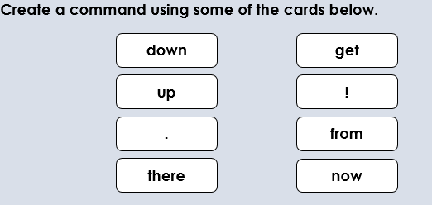
Challenge:

