Hello and Happy Wednesday Athena and Odysseus!
Today you are thinking about the Year 1 and Year 2 common exception / high frequency words (tricky words). These are spellings that you cannot phonetically sound out! They are red words- and remember our phonics rules….
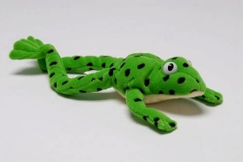
IF THEY’RE RED, YOU CANNOT FRED!
This means Fred can’t sound talk, so you must learn the spellings and read them by sight.

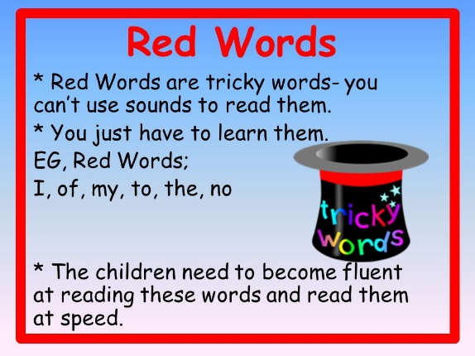
To become a fantastic writer, we must spell many of these words in our writing correctly – so, we must make sure we are practising using them in sentences whenever we can!

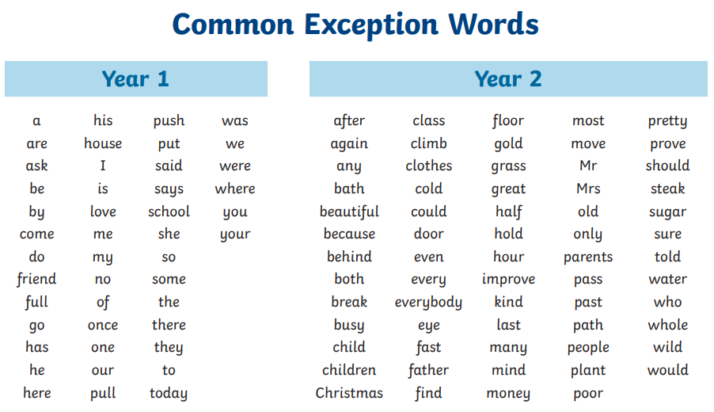
Below are some of the words we have been working on so far this year. Over the following weeks, please practise these and try to use them in all writing contexts.
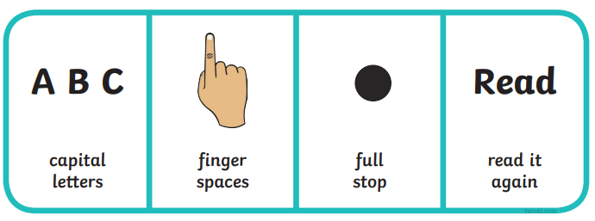
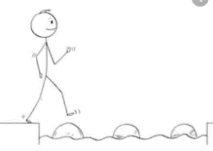
Year 2 Writing
Lesson 3 Steppingstone activity
Wednesday 1st April 2020
LO: To use and spell tricky words correctly
Success Criteria:
- Read the sentence
- Read the tricky words in the list
- Choose which tricky word you need to fill the gap and write your sentence
- I am going to _____ park.

- Can you put _____ hat on?

- _____ you ok?

- I feel happy _________ !

- My mum ________ you can come over.

Challenge: Make up your own sentences using the tricky words

Year 2 Writing
Lesson 3
Wednesday 1st April 2020
LO: To spell many common exception words
Success Criteria:
- Read the sentences out loud
- Try using the tricky words to fill the gaps as you read out loud
- Write the sentences, filling in the gaps with the best tricky words
- Please remember to read your sentences back to check you have used: capital letters, finger spaces, handwriting joins, correct spellings and punctuation!
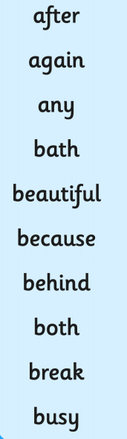
- You can only have pudding __________ your dinner.

- The man was sad ___________ his cart tipped over.

- The sun is shining and it looks so _____________!

- I got very dirty in the mud and now I need a hot __________.

- Can you play with me at ___________ time?

- Do you have ______ coloured pencils I could use?

- _________ you’ve been outside you must wash your hands.

- I’m going to bring _______ my hat and my gloves _______________ it is cold outside.
Challenge: Make up 5 of your own sentences choosing from the tricky word mat.
Can you create different sentence types by using different punctuation marks?
