Year 2 Writing
Lesson 4
Thursday 2nd April 2020
LO: To write descriptive sentences
Hello and Happy Thursday Athena and Odysseus!
Today you are thinking about writing descriptive sentences.
Take a look at the grammar poster below to refresh your memory on the different types of words!
Before you start your work, practise saying sentences using the different word types in the past tense.

Eg: The boy smiled at a beautiful butterfly that gently landed on a bright green leaf.
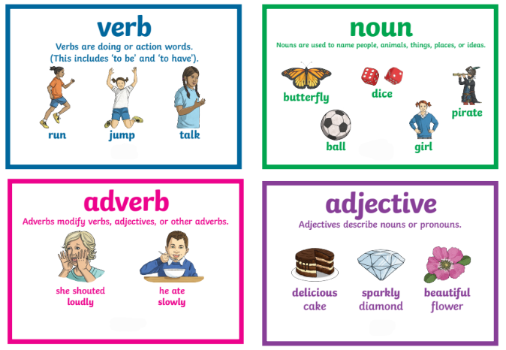

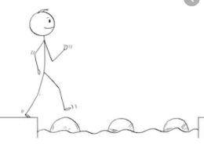
Year 2 Writing
Lesson 4 Steppingstone activity
Thursday 2nd April 2020
LO: To write descriptive sentences
Task (with links):
Watch the clip https://www.literacyshed.com/marshmallows.html
Look at the pictures you have been given.
Create a descriptive sentence for each one, including adjectives.

Success Criteria:
- Look at the picture.
- Choose a noun or create your own.
- Choose one or more adjectives or create your own.
- Write your sentence.
- Read your sentence back to check it makes sense.

EG: The monster had big sharp teeth.
Nouns | Adjectives
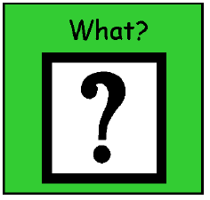  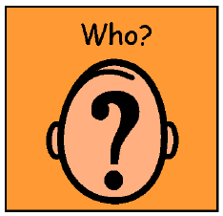  monster  boy  teeth | big  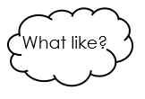  green  yellow  sharp  scared  shocked

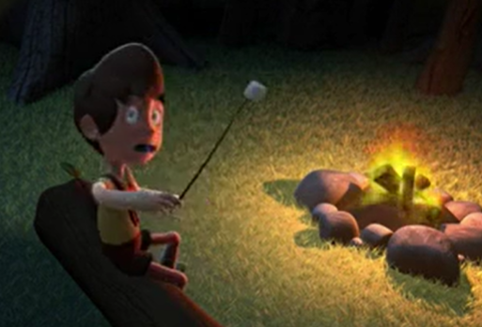
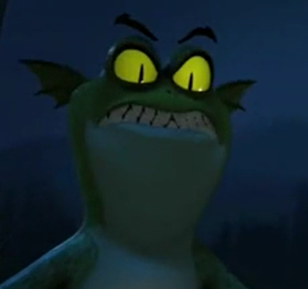

Challenge: Underline your capital letters and full stops the draw a picture to match each of your sentences.
Year 2 Writing
Lesson 4
Thursday 2nd April 2020
LO: To write descriptive sentences
Success Criteria:
Task (with links):
Watch the clip https://www.literacyshed.com/marshmallows.html
- Look at each picture on the page below.
- Write a description for each picture using adjectives (describing words) and verbs (doing words). You can use the word bank words or even better, choose your own!
- Read your sentence back to check it makes sense.

EG: Picture 4- The bright green monster sadly stared into the night sky and wished he had more marshmallows to eat.

Challenge: Can you include different adverbs and conjunctions in your writing?

Word bank:
Adjectives | Nouns | Verbs | Adverbs
huge  green  slimy  young  yellow  sharp  scared  shocked | monster, gremlin, tongue, boy, campfire, marshmallow, pillow | stood, played, sat, gasped, smiled, giggled, ate, ran, stared, longed, wished, jumped | slowly, sneakily, playfully, bouncily, scarily, quickly,
Picture 1 | Picture 2 | Picture 3 | Picture 4
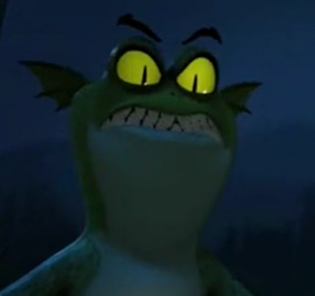 | 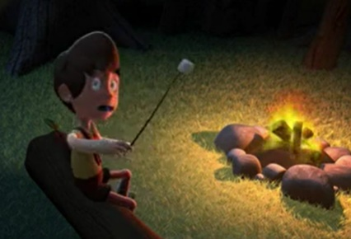 | 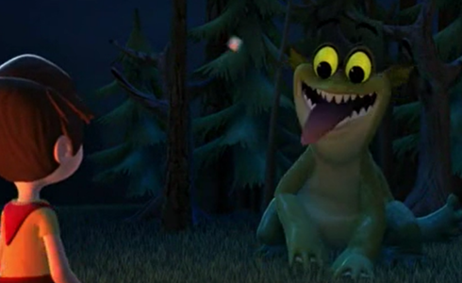 | 