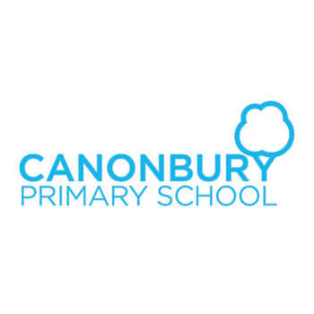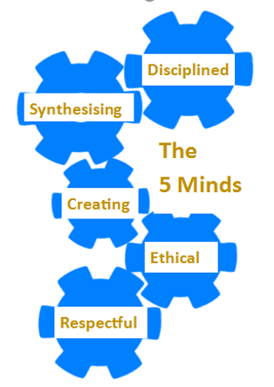

**Year 3 Curriculum Overview**

**Year 3**

**Curriculum Information**

**Autumn 2019**

**Our Canonbury Curriculum -5 Minds for the Future**Our curriculum will enable our children to: acquire substantial knowledge and skills that they remember and can use in the future; make sense of information and communicate their learning to others; ask questions and take flight with ideas to take their learning further; reflect on and exemplify what it is to be a good citizen

Show understanding and appreciation for others who are different to themselves



**Science**

In ourtopic on **Rocks and Soils,** we will be handling rocks, thinking about where they are found and investigating different properties and how to test them. We will learning about how rocks break down to form different soils.

Whilst studying **Light and Dark,** we will be investigating the way that light behaves, thinking about light sources, reflections and shadows and finding ways to experiment to test our ideas and make a conclusion from our findings.

**Maths**

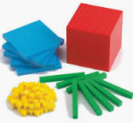We will begin by working on skills and concepts in the following areas:

* **Number:** Place value
* **Number:** addition and subtraction
* **Number:** multiplication and division

We will develop our understanding of new mathematical skills using the concrete, pictorial and abstract approach.

**English**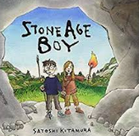The term begins with **‘Stone Age Boy’** which launches us back to the Stone Age where we learn about how ancient people lived, but realise that in many ways they were the same as us.

We will be consolidating Year 2 writing features to ensure that all children have a firm basis upon which to build the Year 3 English Curriculum and some to extend their learning beyond that.

**Topic**

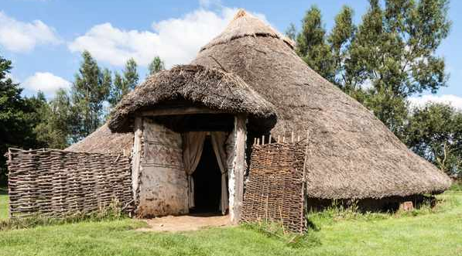

We are going to learn about British pre-history: Stone Age, Bronze Age and Iron Age. We have planned an exciting trip to a Bronze Age camp where we will experience what life was like a long time ago. We will be looking at historical sources, comparing modern life with pre-historic life, cooking bread and making models to immerse the children in their learning.

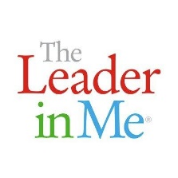

**Art**

Children will look at cave art and make their own paints from natural materials. They will also make clay pots.

**Spanish**

Children will be learning simple phrases and vocabulary

* numbers up to 30, and tens up to 100.
* Greetings
* Colours
* fruit

**Music**

Children will all be given a recorder and learning to play the instrument with a specialist music teacher.

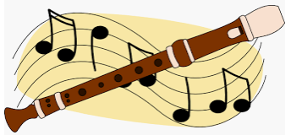

**Key Dates**

**19th September**

Swimming lessons- half term block for Hermes Class

**30th September**

Trip to Celtic Harmony Pre-historic camp

**31st October**

Swimming lessons- half term block for Hestia Class

**7th November**

Y3 assembly for parents

**Computing**

* E-safety
* Programming

**Religious Studies**



We will be exploring what different people believe about God and how this can help them try to live a good life.

We will be moving on to think about why the bible is important to Christians and exploring some of the stories and the messages they teach to followers.

**PSHE**

* Keeping safe and managing risks when things go wrong.
* Bullying: see it, say it, stop it
* Leader in Me: 7 Habits

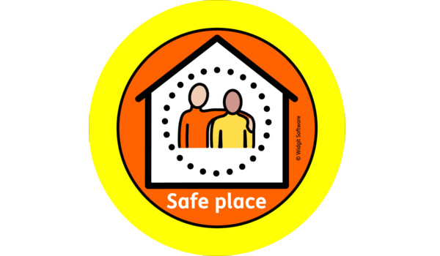

**Physical Education**

* Football with Team Kick start on Tuesdays
* Swimming with qualified instructors on Thursdays on a half-termly rotation (Hermes 1st, Hestia 2nd)