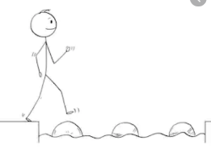
Year 3 Maths
Steppingstone activity
Lesson 10
LO: To apply my knowledge of addition and subtraction
Success Criteria:
- Work out the number sentence on each side of the calculation
- Write the answer to each underneath
- Compare the answers
- Draw the correct crocodile symbol > < or = inbetween the number sentences

Model:
Now you try:
- 4+6 ⃝ 2+3
- 10-3 ⃝ 6+1
- 12-6 ⃝ 5+4

3+7
Remember, greedy Mr Crocodile always eats the bigger amount!
4+2

10
6

5+2
If the amount is the same on either side, we do an equals sign = .
6+1

7
7

Year 3 Maths
Lesson 10
LO: To apply my knowledge of column addition and subtraction
Success Criteria:
- Look at the bar model
- If the whole bar is missing then ADD the parts together to find the missing answer
- If one of the part bars is missing then SUBTRACT the part you have from the whole to find the missing answer
Now you try:
Model
?
65 | 137
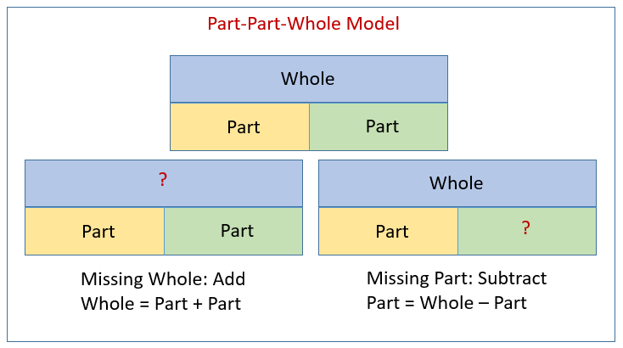

Here we have a missing whole, so we have to ADD.
Use column addition to solve 65+137 =
352
48 | ?

Here we have a missing part, so we have to SUBTRACT.
Use column subtraction to solve 352-48 =

Year 3 Maths - Main activity
Complete at least 2 columns, more if you can!
Task 1 | Task 2 | Task 3 | Task 4
1. Use deines notation to solve these calculations:  a) 15 + 12 = b) 56 – 25 =  c) 24 – 13 = d) 24 + 34 =  e) 18 + 21 = f) 18 – 7 =  2. Write < > or = to make these correct:  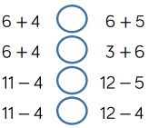  3. Use column method to solve these calculations:  a) 24 + 53 =  b) 87 – 62 =  c) 45 + 37 =  d) 63 – 28 = | 1.  a)  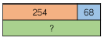? =  b)  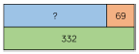 ? =  c)  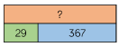 ? =  2. Write < > or = to make these correct:  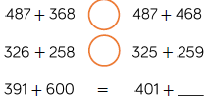 | 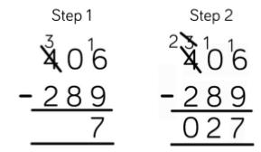  Eva is working out 406-289. Here is her working out:  Explain her mistake.  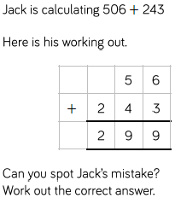  What should her answer be? | Remember: Difference is another way of saying subtract.  e.g. the difference between 25 and 23 means 25 - 23 = 2  Start with the number 888.  Roll a dice three times, to make a 3-digit number.  Subtract the number from 888.  What number have you got now?  What’s the smallest possible difference?  What’s the largest possible difference?  What if all the digits have to be different?  Will you ever find a difference that is a multiple of 10? Why?  Do you have more odd or even differences?

