Year 3 day 6 Answers
Task 1 | Task 2 | Task 3 | Task 4
Practice  a) 24 + 35 = 59  b) 13 + 29 = 42  c) 25 + 17 = 42  d) 33 + 18 = 51  e) 48 + 14 = 62  f) 27 + 25 = 52  g) 14 + 34 = 48 | 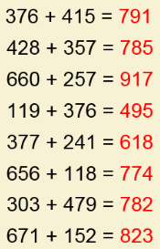  Practice | Reasoning  Jack has not lined his numbers up in the correct place value columns.  Eva is not correct because she forgot to carry her 10 ones into the tens column. That means the tens column should add up to 90 not 80.  The answer should be 292. | Problem solving  No exchange Exchange 10 ones Exchange 10 tens  910+79 342+35 375+18 456+27 912+79 456+72

