Year 3 Maths – Day 7 Answers
Complete at least 2 columns, more if you can!
Task 1 | Task 2 | Task 3 | Task 4
Practice  Use base ten (deines) jottings to work these out:  a) 45 + 23 = 68  b) 17 + 19= 36  c) 46 + 42= 88  d) 39 + 15=54  e) 25 + 25= 50  f) 18 + 26= 44  g) 16 + 34=50 | Practice  Use column addition to solve these:  - 475  - 644  - 443  - 1272  - 661 | Reasoning  Complete the calculations by filling in the missing digits: 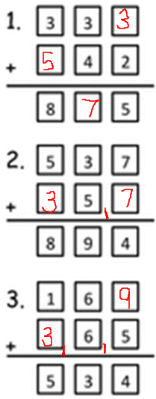 | Problem solving  