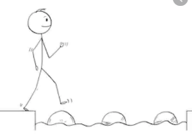
Year 3 Maths
Steppingstone activity
Lesson 7
LO: To use Base 10 jottings for addition with and without exchanges
Success Criteria:
- Write the number sentence (e.g. 23 + 18 =)
- Represent the numbers as tens and ones using Base 10 jottings
- Count the tens first, crossing off as you do
- Count the ones, continuing from your last ten (e.g. 10, 20, 30 then 31, 32…)
- Write the answer to complete your number sentence

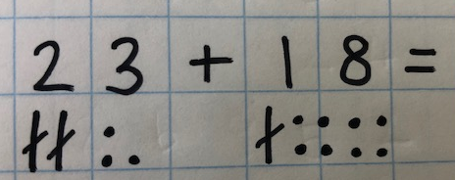
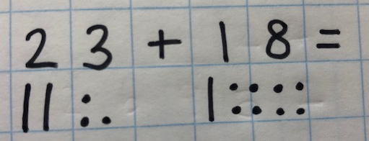
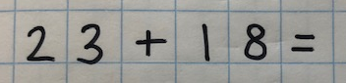
Model:
1.
3.
2.

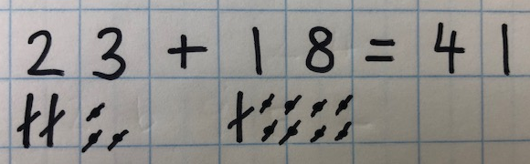
5.
4.

Keep practicing this method!

Year 3 Maths
Lesson 7
LO: To use column addition with exchanges
Success Criteria:
- Line your numbers up in the place value columns
- Add the ONES, write answer below and any exchanges
- Add the TENS write answer below and any exchanges
- Add the hundreds
Model
451 + 487 =
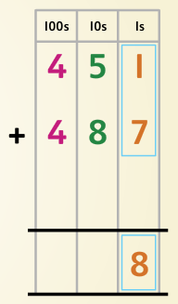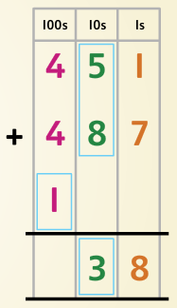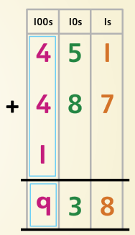
451 + 487 = 938

Year 3 Maths - Main activity
Complete at least 2 columns, more if you can!
Task 1 | Task 2 | Task 3 | Task 4
Practice  Use base ten (deines) jottings to work these out:  a) 45 + 23  b) 17 + 19  c) 46 + 42  d) 39 + 15  e) 25 + 25  f) 18 + 26  g) 16 + 34 | Practice  Use column addition to solve these:  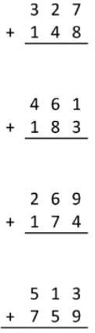  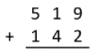 | Reasoning  Complete the calculations by filling in the missing digits: | Problem solving  