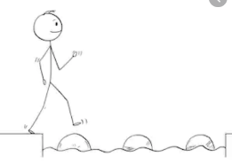
Year 3 Maths
Steppingstone activity
Lesson 8
LO: To use Base 10 jottings for subtraction
Success Criteria:
- Write the number sentence (e.g. 25 - 13 =)
- Represent the biggest number as tens and ones using Base 10 jottings
- Cross off the smaller number from the Base 10 jottings (start with tens, then cross off ones)
- Draw what Base 10 you have left over
- Write the answer to complete your number sentence

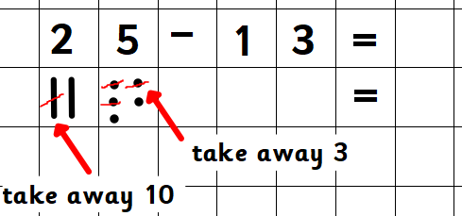
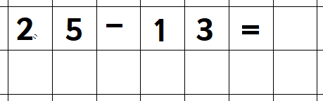
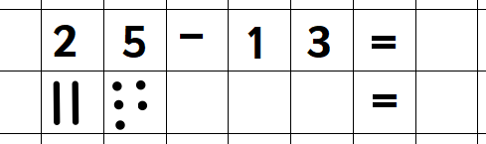
Model:
1.
3.
2.

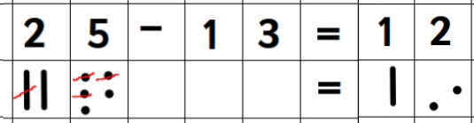
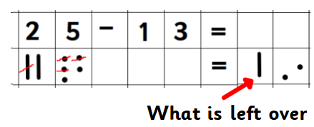
5.
4.

Now you try:
- 26 - 23
- 47 - 25
- 38 - 17
- 22 - 11

Year 3 Maths
Lesson 8
LO: To use column subtraction with exchanges
Success Criteria:
- Put the larger number on the top
- Put the smaller number below (in the correct place value columns!)
- Subtract the units (top number - bottom number)
- If this is not possible, exchange from the tens column
- Now repeat step 3.
- Subtract the 10s (top number - bottom number)
- If this is not possible, exchange from the hundreds column
- Now repeat step 6
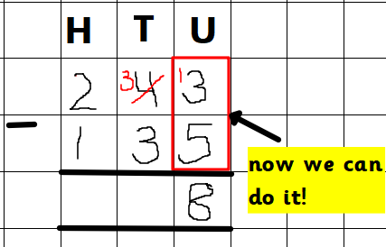
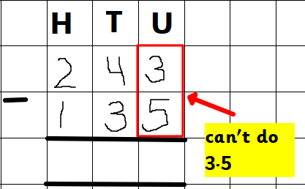
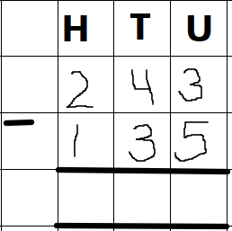
Model
4.
2.
1.
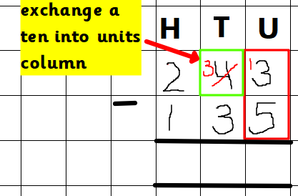
3.

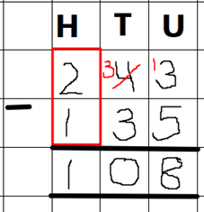
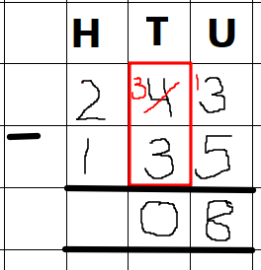
6.
5.

Year 3 Maths - Main activity
Complete at least 2 columns, more if you can!
Task 1 | Task 2 | Task 3 | Task 4
Practice  Use column subtraction to solve these:  a) 45 - 38 =  b) 32 - 27 =  c) 14 - 8 =  d) 36 - 19 =  e) 21 - 15 =  f) 52 - 37 = | Practice  Use column subtraction to solve these:  a) 133 - 25 =  b) 224 - 18 =  c) 232 - 40 =  d) 319 - 130 =  e) 255 - 171 =  f) 243 - 65 = | Reasoning  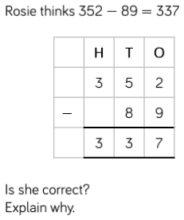 | 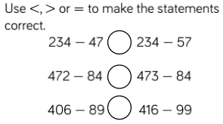  Problem solving  Calculate the missing number in each model:  a)  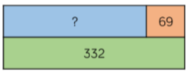  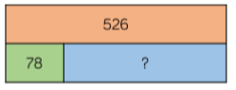  b)  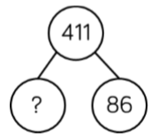  c)

