Year 3 Maths – Day 7 Answers
Complete at least 2 columns, more if you can!
Task 1 | Task 2 | Task 3 | Task 4
a) 22–16 =6  b) 73-59 =14  c) 92-88 =3  d) 42-29 =13  e) 87-69 =18 | a) 254-177 =77  b) 892-238 =654  c) 558-427 =131  d) 626-215 =411  e) 283-45 =238 | 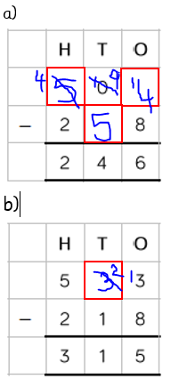 | 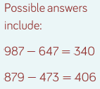  - 829 points  - 127 more points  - 502 points

