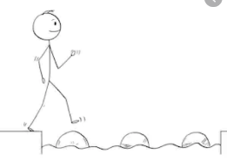
Year 3 Maths
Steppingstone activity
Lesson 9
LO: To use Base 10 jottings for subtraction
Success Criteria:
- Write the number sentence (e.g. 25 - 13 =)
- Represent the biggest number as tens and ones using Base 10 jottings
- Cross off the smaller number from the Base 10 jottings (start with tens, then cross off ones)
- Draw what Base 10 you have left over
- Write the answer to complete your number sentence

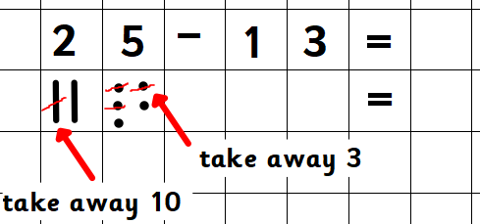
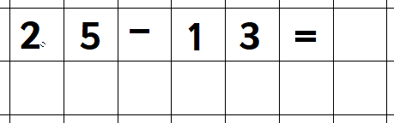
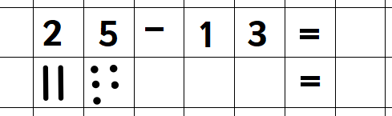
Model:
1.
3.
2.

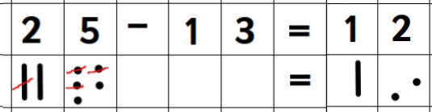
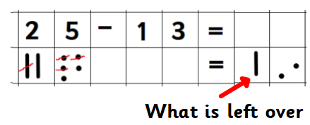
5.
4.

Now you try:
- 23 – 21
- 57 - 26
- 36 - 12
- 42 - 21

Year 3 Maths
Lesson 9
LO: To use column subtraction with exchanges
Success Criteria:
- Put the larger number on the top
- Put the smaller number below (in the correct place value columns!)
- Subtract the units (top number - bottom number)
- If this is not possible, exchange from the tens column
- Now repeat step 3.
- Subtract the 10s (top number - bottom number)
- If this is not possible, exchange from the hundreds column
- Now repeat step 6
Model
4.
2.
1.
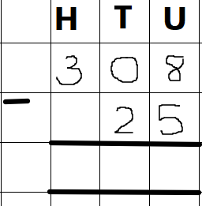
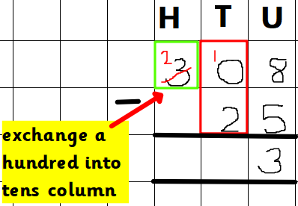
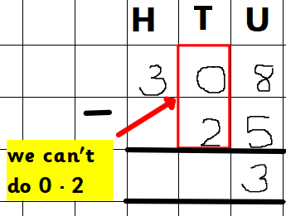
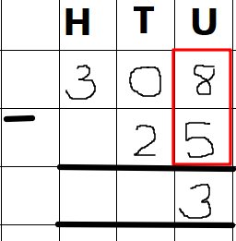
3.

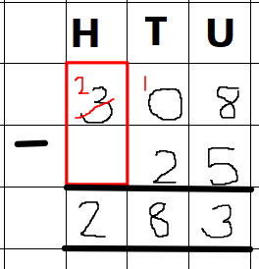
6.
5.
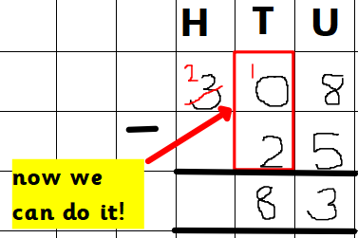

Year 3 Maths - Main activity
Complete at least 2 columns, more if you can!
Task 1 | Task 2 | Task 3 | Task 4
Practice  Use column subtraction to solve these:  a) 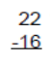  b) 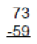  c) 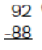  d) 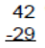  e) 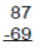 | Practice  Use column subtraction to solve these:  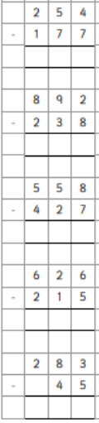 | Reasoning  Work out the missing numbers:  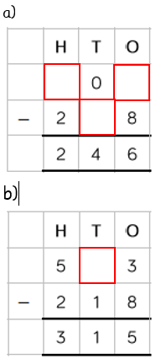 | 1. Use the digit cards to complete the calculation:  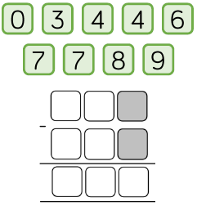  The digits in the shaded boxes must be odd.  Can you find more than one answer?  2. Sarah and Juliet are playing a game. Sarah scores 351 points and Juliet scores 478 points.  a) How many points do they score altogether?  b) How many more points does Juliet score than Sarah?  Next day, they play the game again. Sarah scores 281, Juliet scores 60 less than Sarah.  c) How many points do they score altogether?

