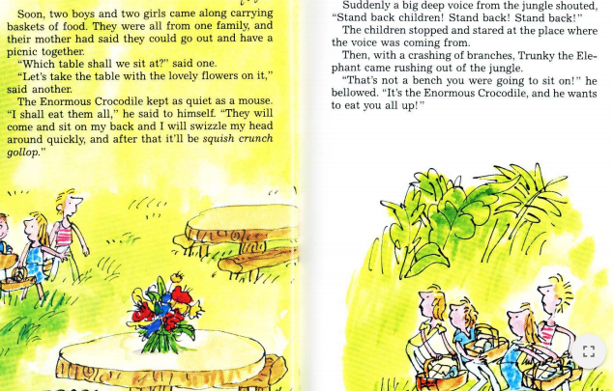
Year 3 Reading Week 2. Day 3.
Text: The Enormous Crocodile
If you have the book, make sure you have read up to end of P 44 (That’s not a bench….he wants to eat you all up.)

Reading focus: Explain words
Find these words from the text and explain their meanings:
- Fearsome dragon.
- All sorts of children came flocking into the fair.
- The Enormous crocodile cursed the Roly-Poly Bird.
- I will swizzle my head around.
- “That’s not a bench you were going to sit on, “he bellowed.
Re-write the sentences above and use an alternative word with the same meaning.

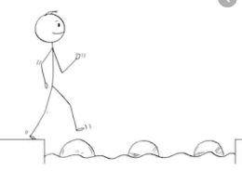
Year 3 Reading
Steppingstone activity
Day 3
Reading Focus: Explain words.
If you have the book, make sure you have read up to end of P 44 with an adult or older sibling. (That’s not a bench….he wants to eat you all up.)
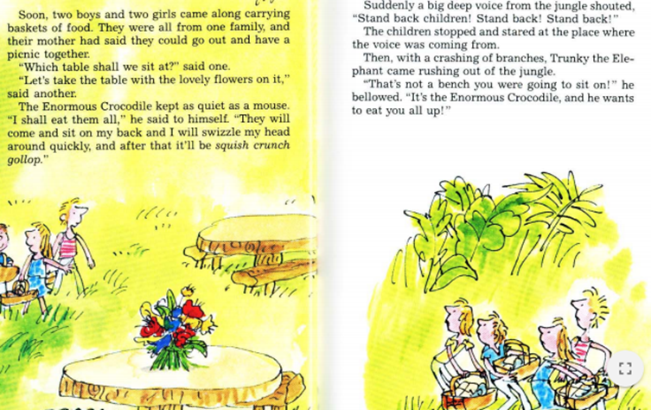

Draw a picture to show the meaning of these words:
- Merry go round
- Fearsome dragon.
- Something came swishing and swooshing out of the sky.
If there are any other tricky words, talk about their meanings with your adults.

